**Az-140 – Configuring and Operating Microsoft Azure Virtual Desktop**

Contents

Lab 01 - Prepare for deployment of Azure Virtual Desktop (Azure AD DS) 2

Exercise 0: Increase the number of vCPU quotas 2

Task 1: Identify current vCPU usage 2

Task 2: Request vCPU quota increase 2

Exercise 1: Implement an Azure Active Directory Domain Services (AD DS) domain 3

Task 1: Create and configure an Azure AD user account for administration of Azure AD DS domain 3

Task 2: Deploy an Azure AD DS instance by using the Azure portal 5

Task 3: Configure the network and identity settings of the Azure AD DS deployment 7

Exercise 2: Configure the Azure AD DS domain environment 9

Task 1: Deploy an Azure VM running Windows 10 by using an Azure Resource Manager QuickStart template 9

Task 2: Deploy Azure Bastion 10

Task 3: Review the default configuration of the Azure AD DS domain 11

Task 4: Create AD DS users and groups that will be synchronized to Azure AD DS 14

Lab 02A - Create and configure host pools and session hosts (Azure AD DS) 17

Exercise 1: Configure an Azure Virtual Desktop environment 17

Task 1: Prepare AD DS domain and the Azure subscription for deployment of an Azure Virtual Desktop host pool 17

Task 2: Deploy an Azure Virtual Desktop host pool 17

Task 3: Configure Azure Virtual Desktop application groups 20

Task 4: Configure Azure Virtual Desktop workspaces 24

Exercise 2: Validate Azure Virtual Desktop environment 26

Task 1: Install Microsoft Remote Desktop client (MSRDC) on a Windows 10 computer 26

Task 2: Subscribe to a Azure Virtual Desktop workspace 27

Task 3: Test Azure Virtual Desktop apps 28

Lab 02B - Implement and manage storage for AVD (Azure AD DS) 30

Exercise 1: Configure Azure Files to store profile containers for Azure Virtual Desktop 30

Task 1: Create aazn Azure Storage account 30

Task 2: Create an Azure Files share 30

# Lab 01 - Prepare for deployment of Azure Virtual Desktop (Azure AD DS)

## Exercise 0: Increase the number of vCPU quotas

### Task 1: Identify current vCPU usage

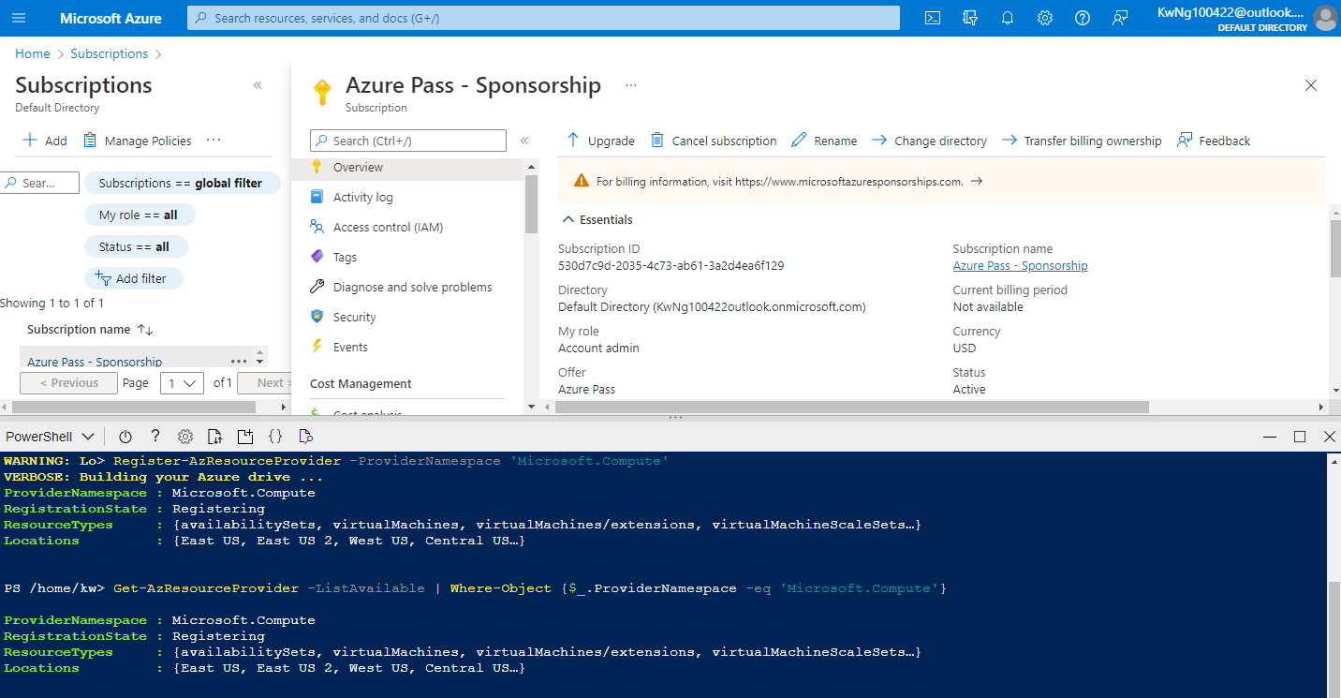

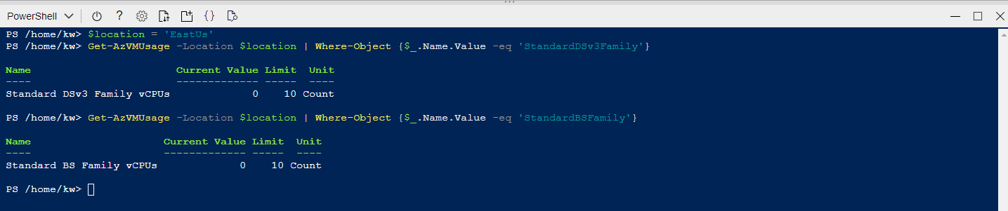

### Task 2: Request vCPU quota increase

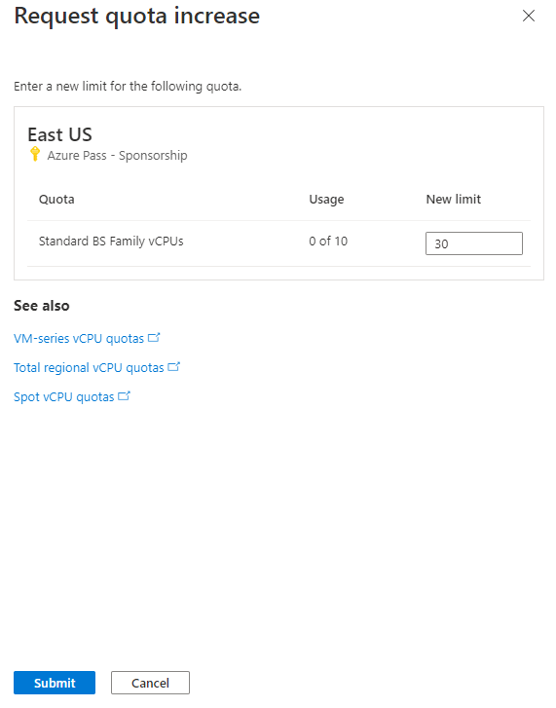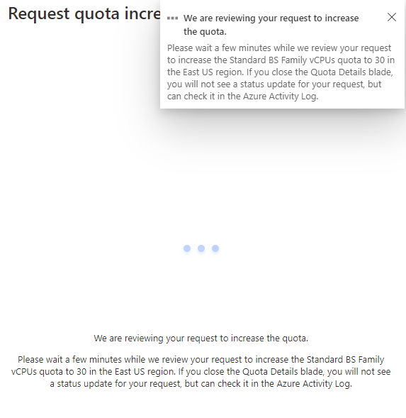

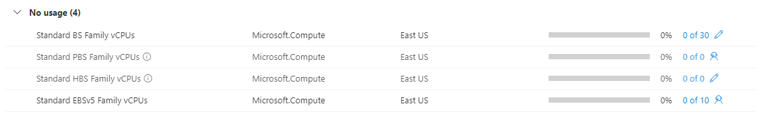

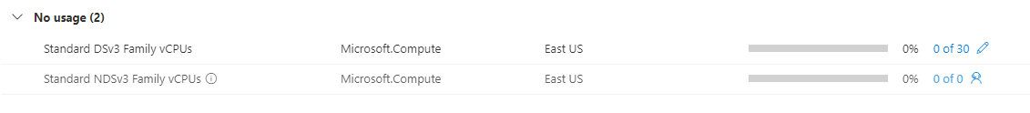

#Send Support ticket to increase the vCPUs quota

## Exercise 1: Implement an Azure Active Directory Domain Services (AD DS) domain

### Task 1: Create and configure an Azure AD user account for administration of Azure AD DS domain

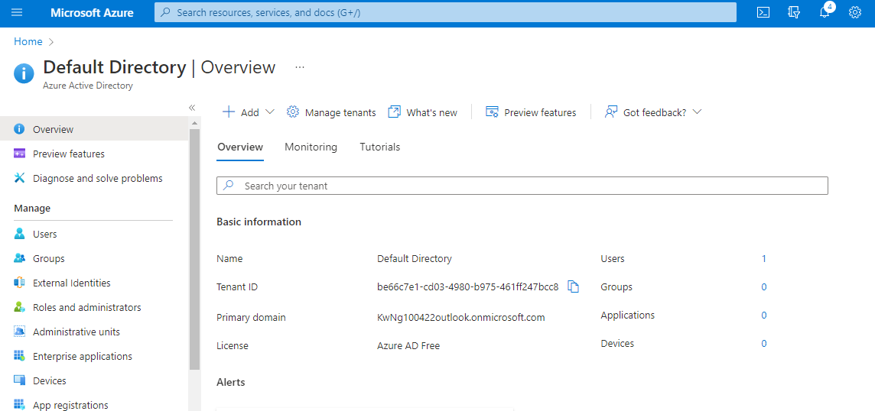

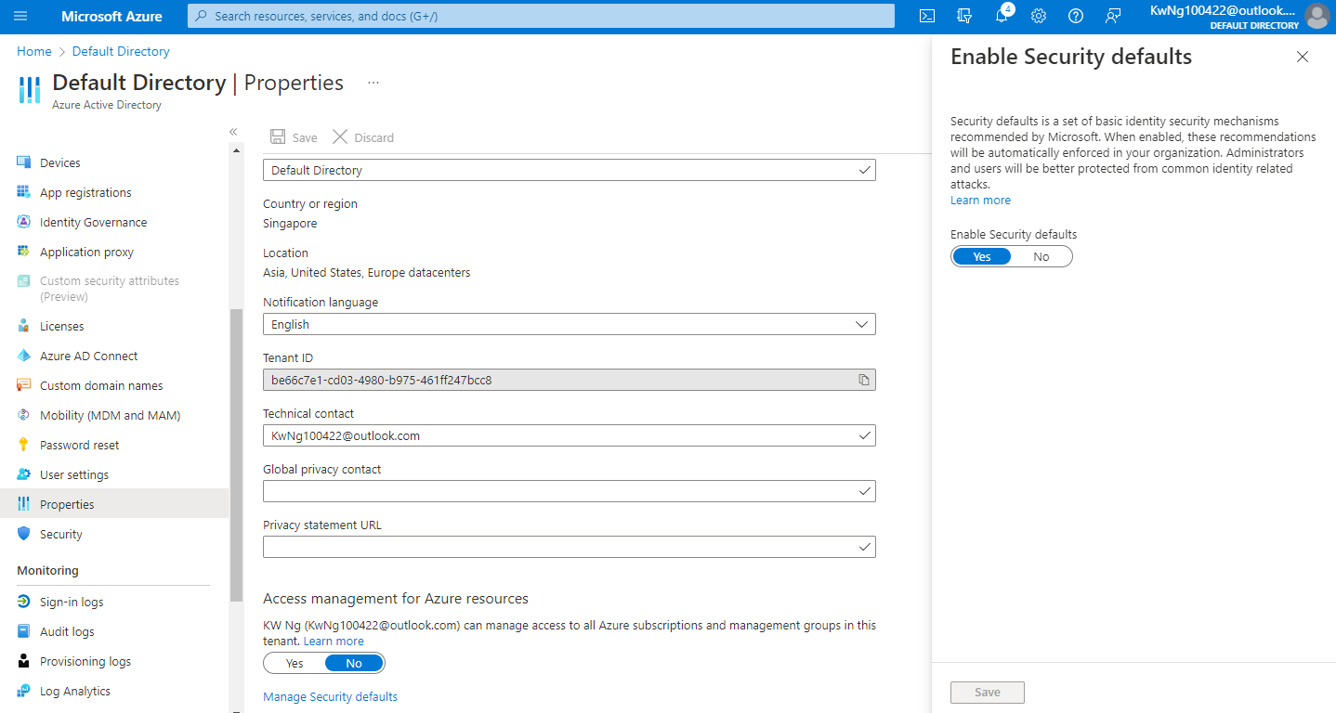

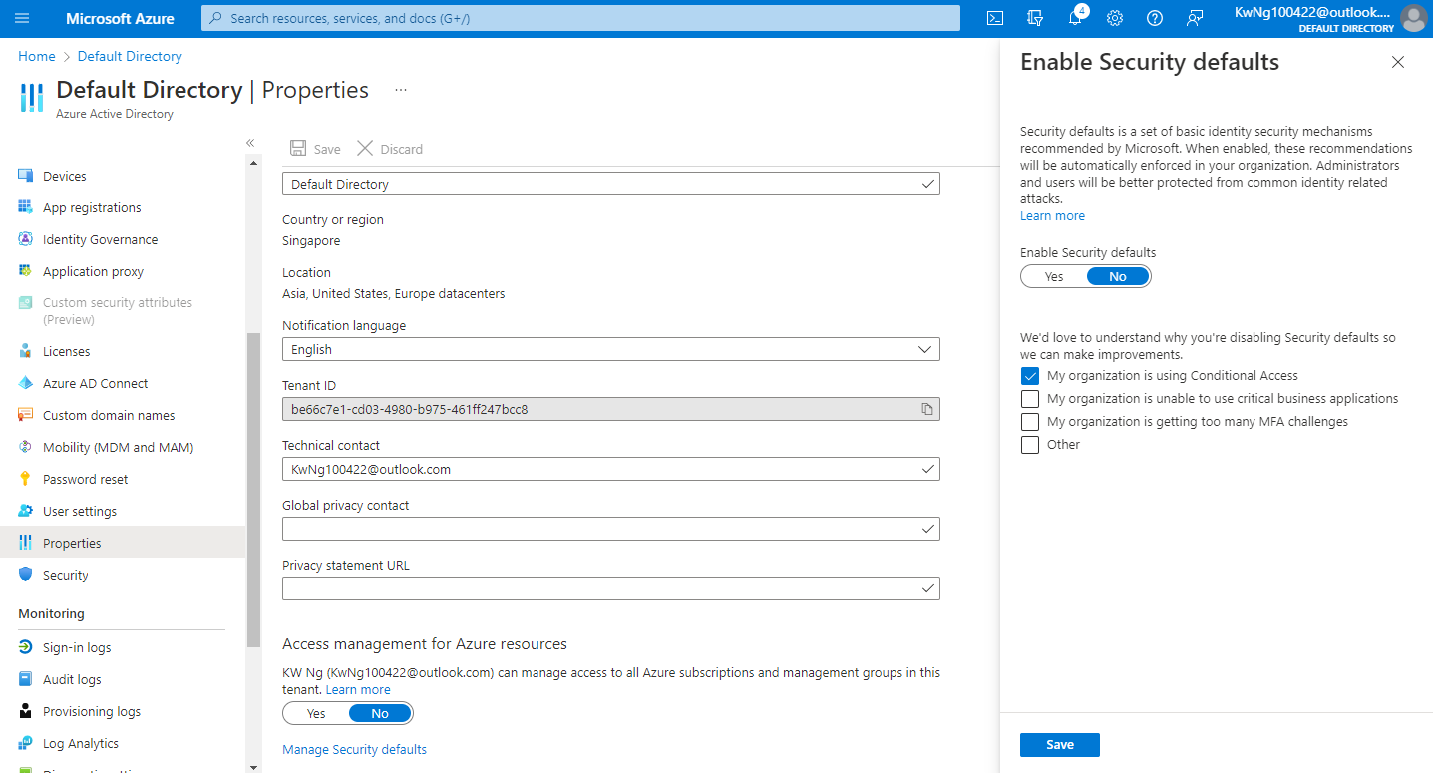

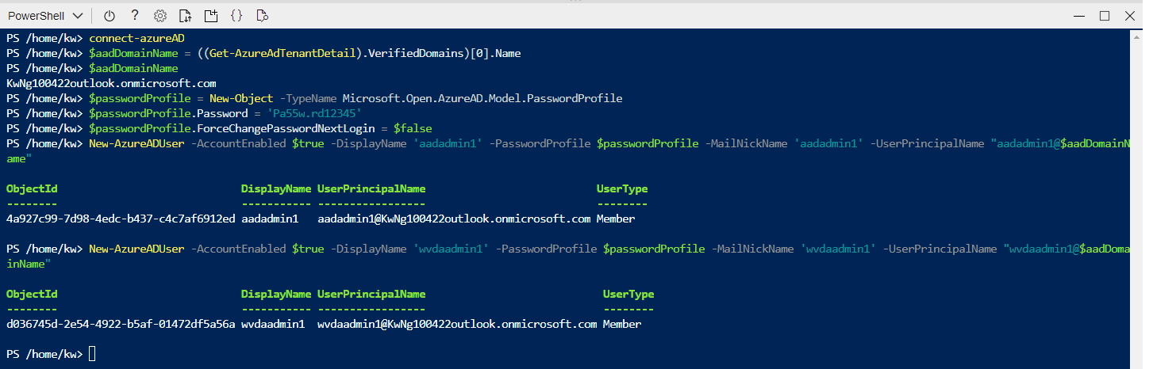

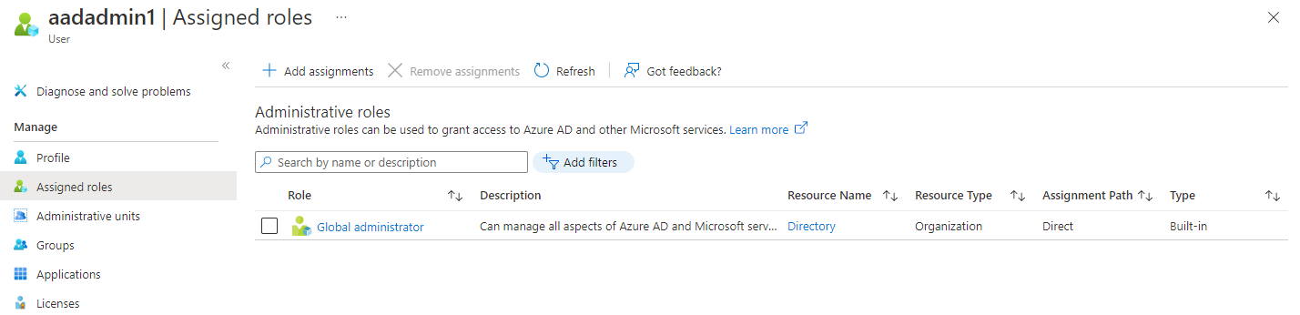

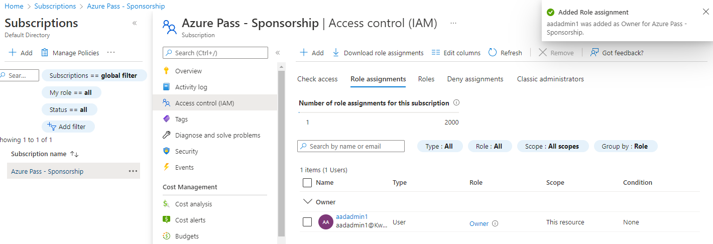

### Task 2: Deploy an Azure AD DS instance by using the Azure portal

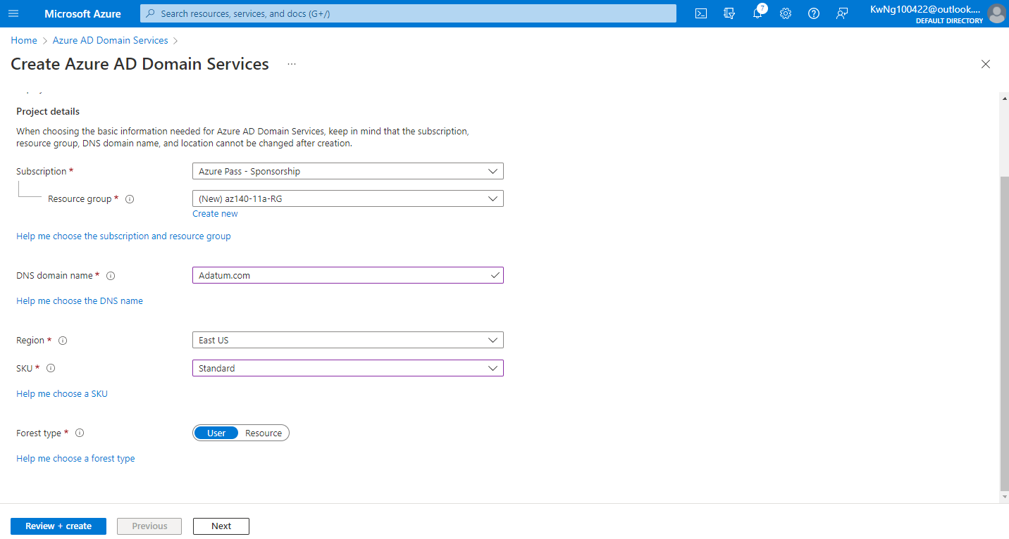

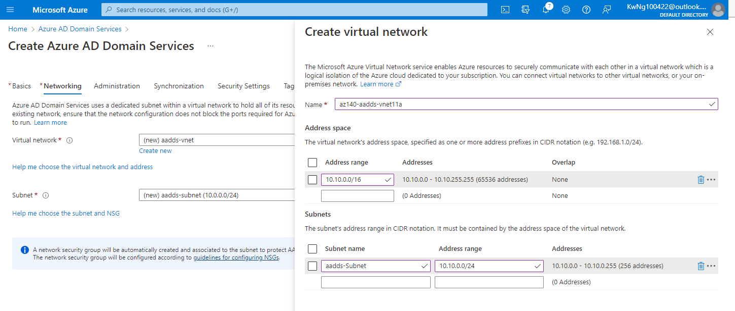

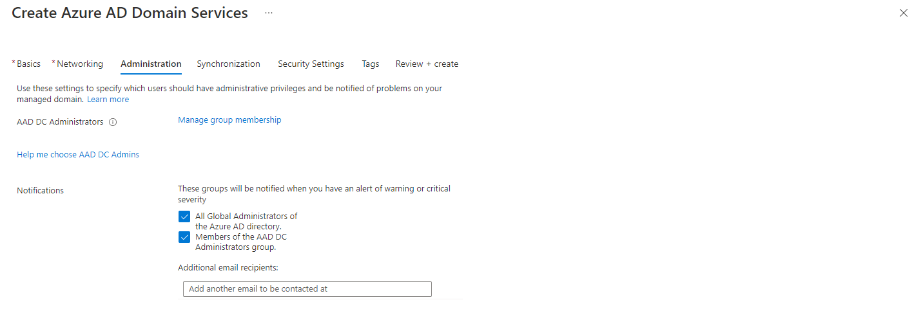

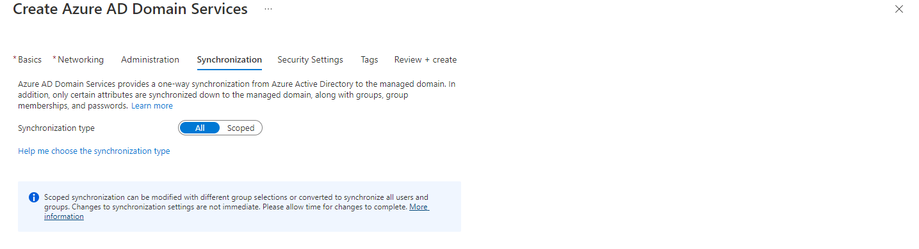

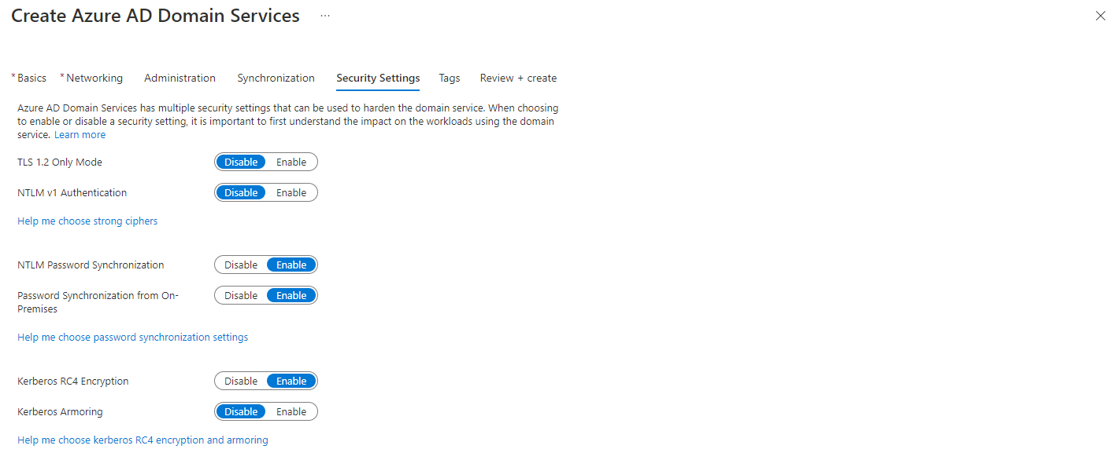

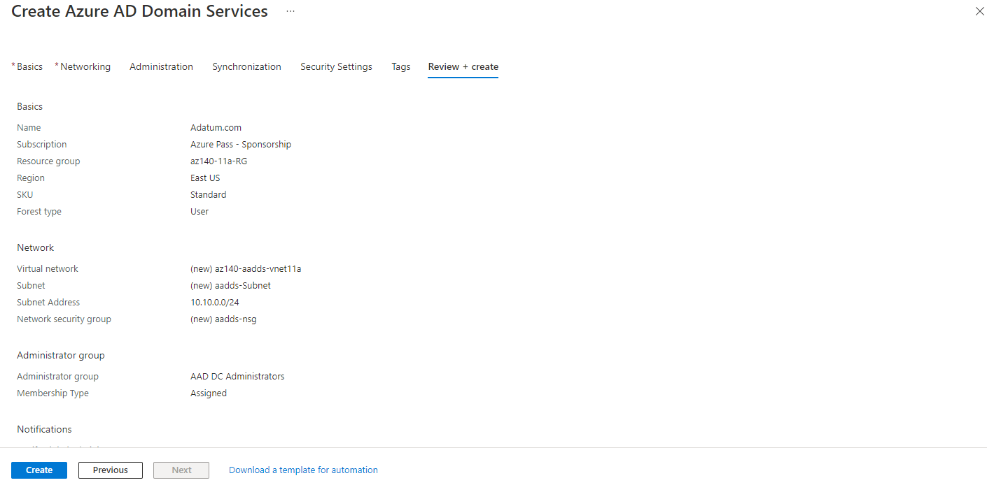

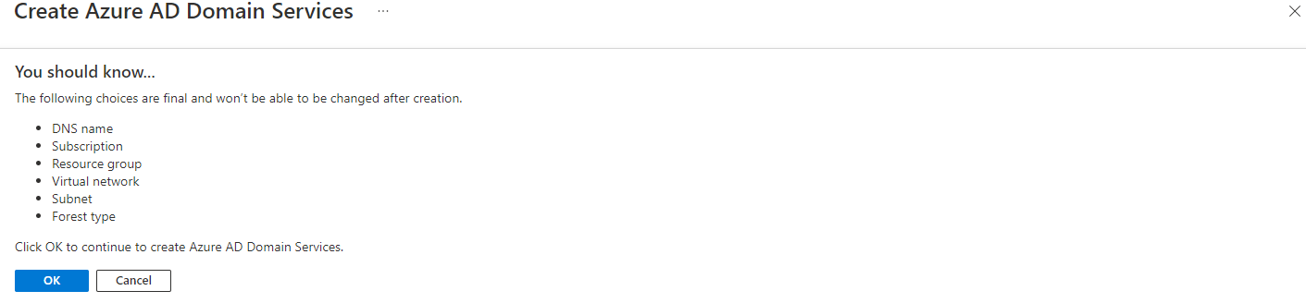

Note: Wait for the deployment to complete before you proceed to the next exercise. This might take about 60 minutes.

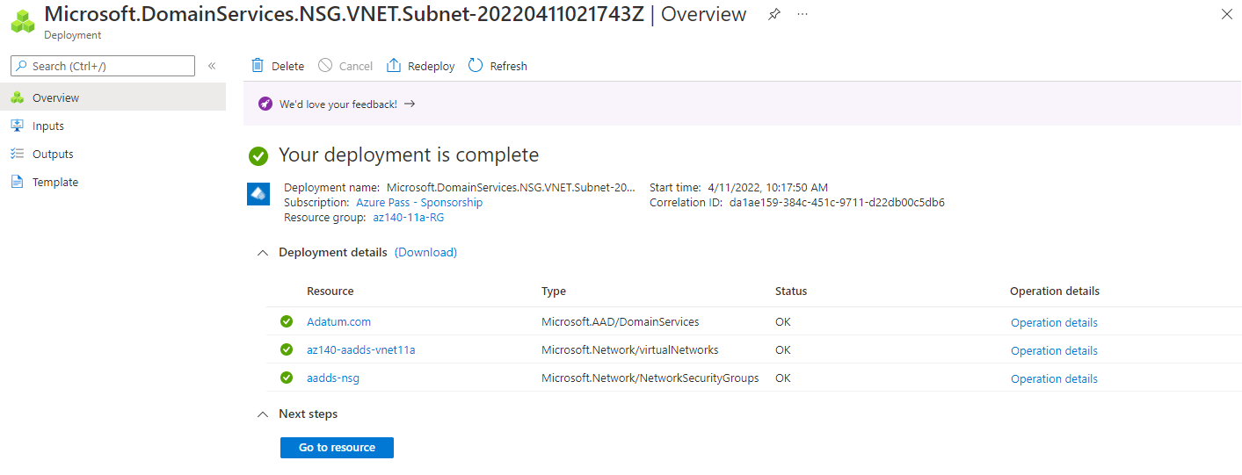

### Task 3: Configure the network and identity settings of the Azure AD DS deployment

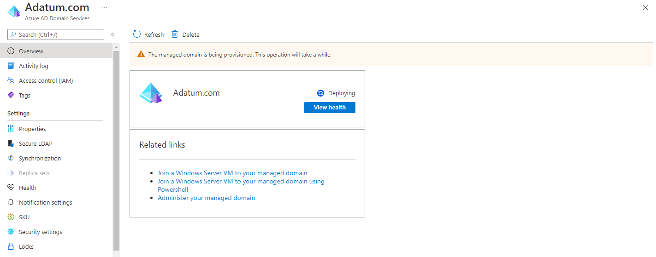

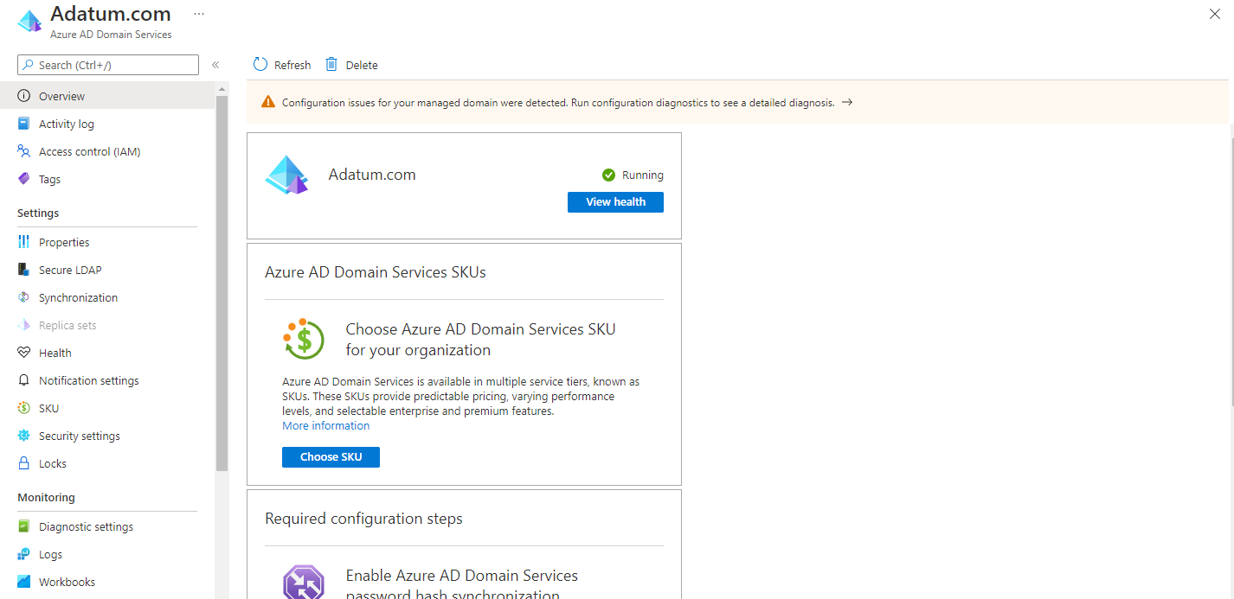

From Deploying state to Running state is about 30 mins.

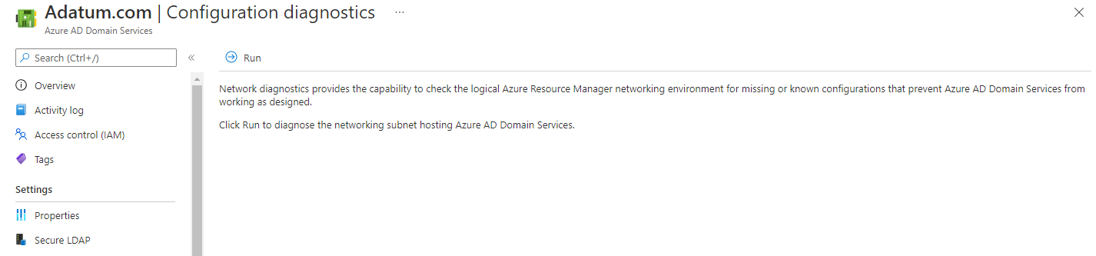

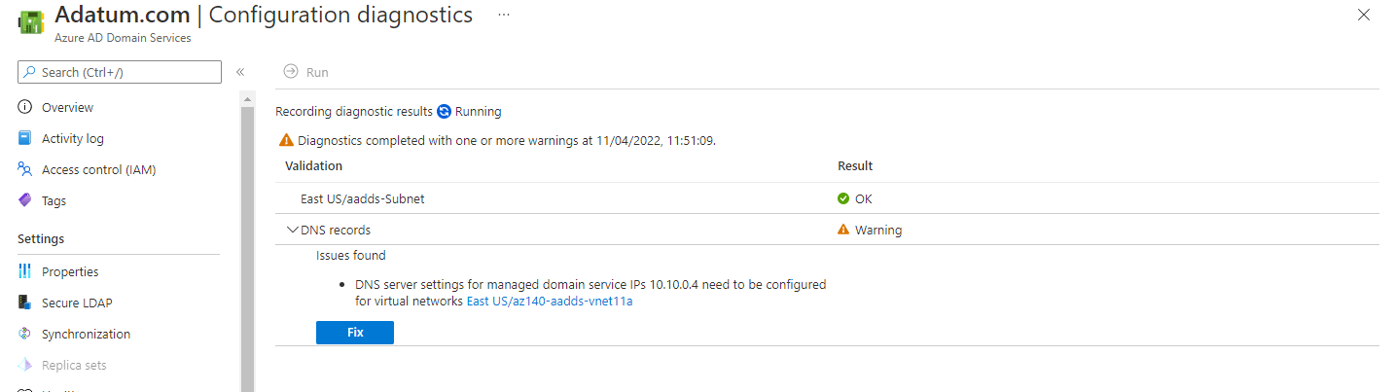

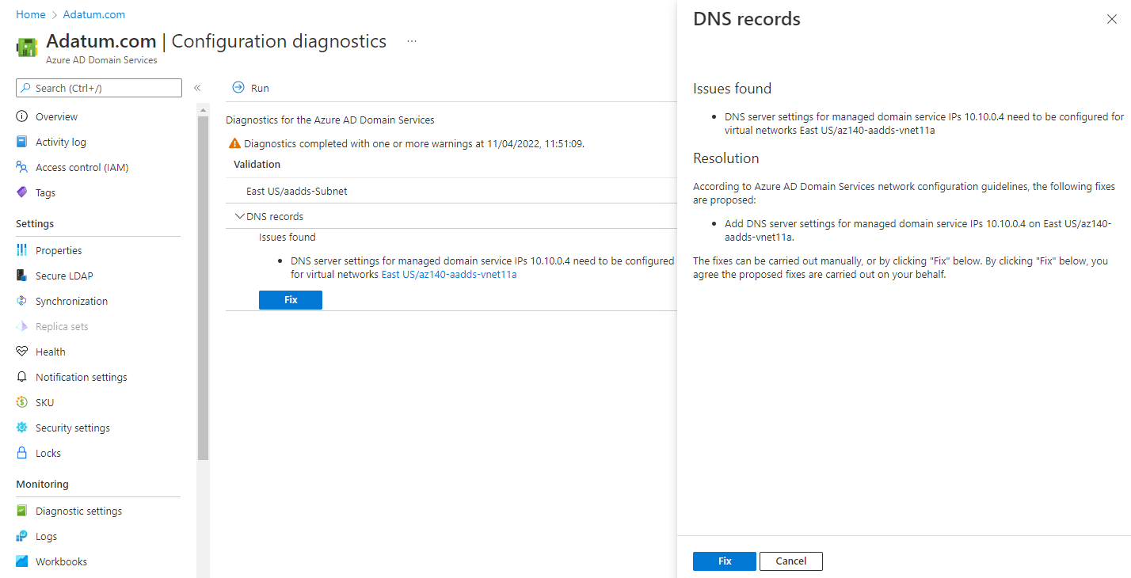

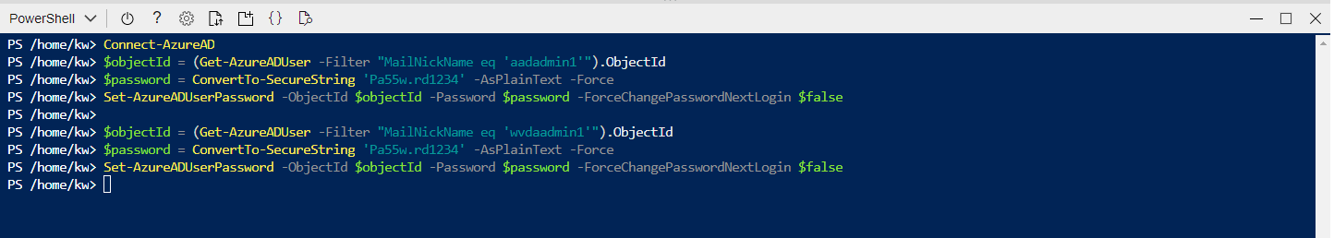

## Exercise 2: Configure the Azure AD DS domain environment

### Task 1: Deploy an Azure VM running Windows 10 by using an Azure Resource Manager QuickStart template

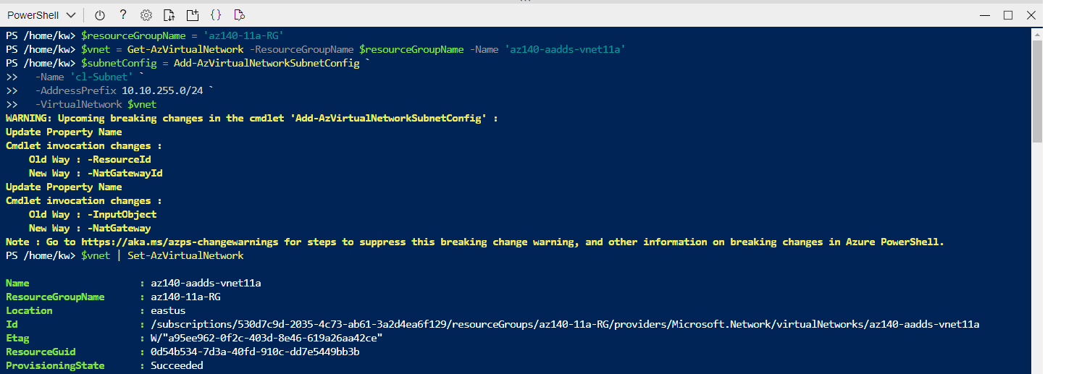

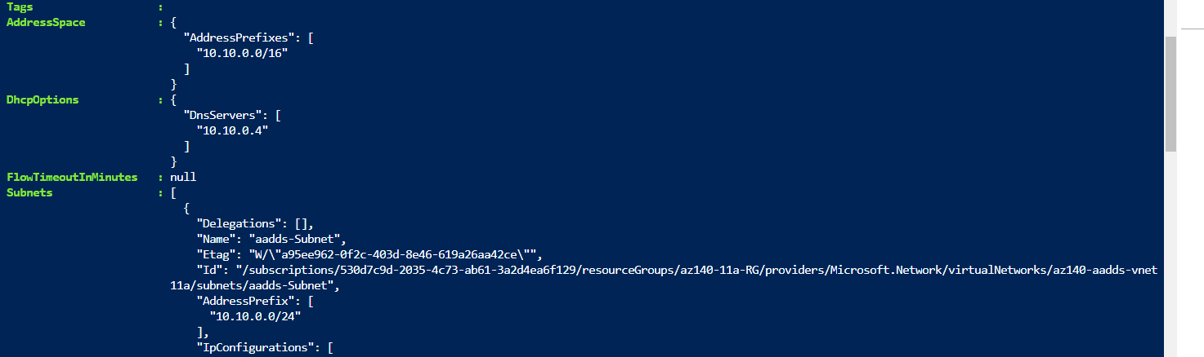

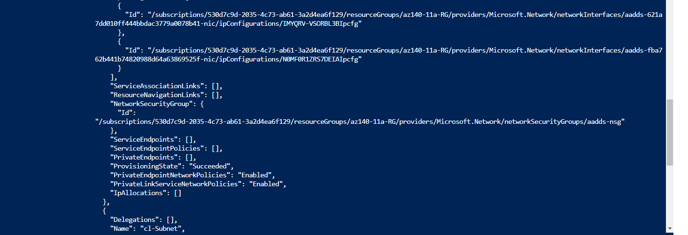

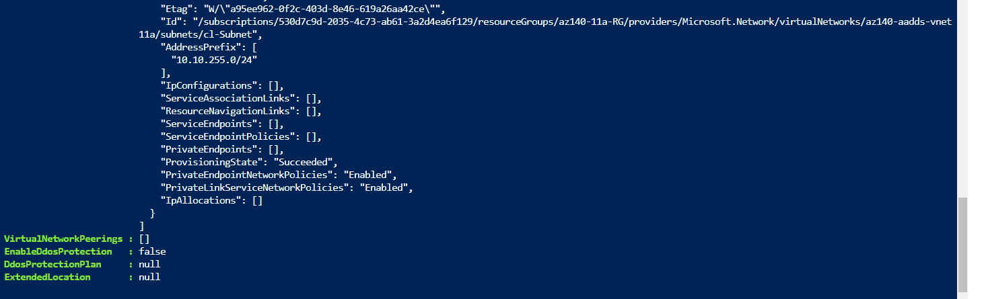

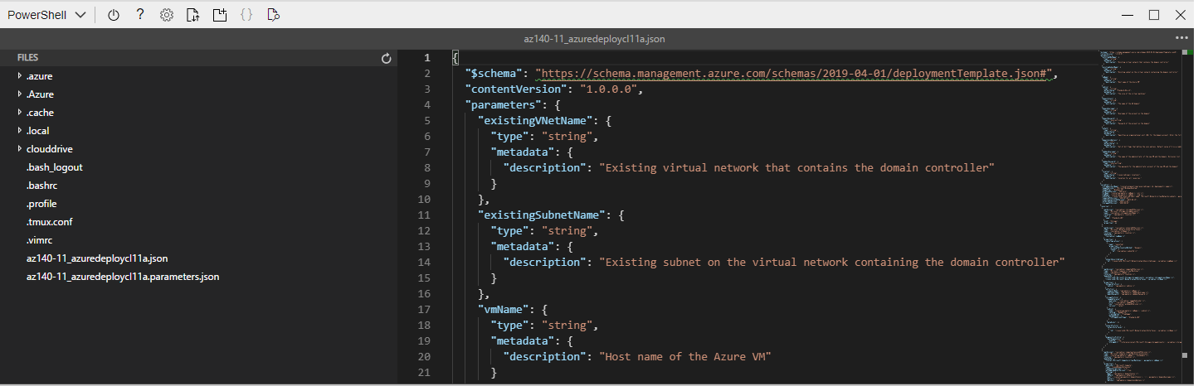

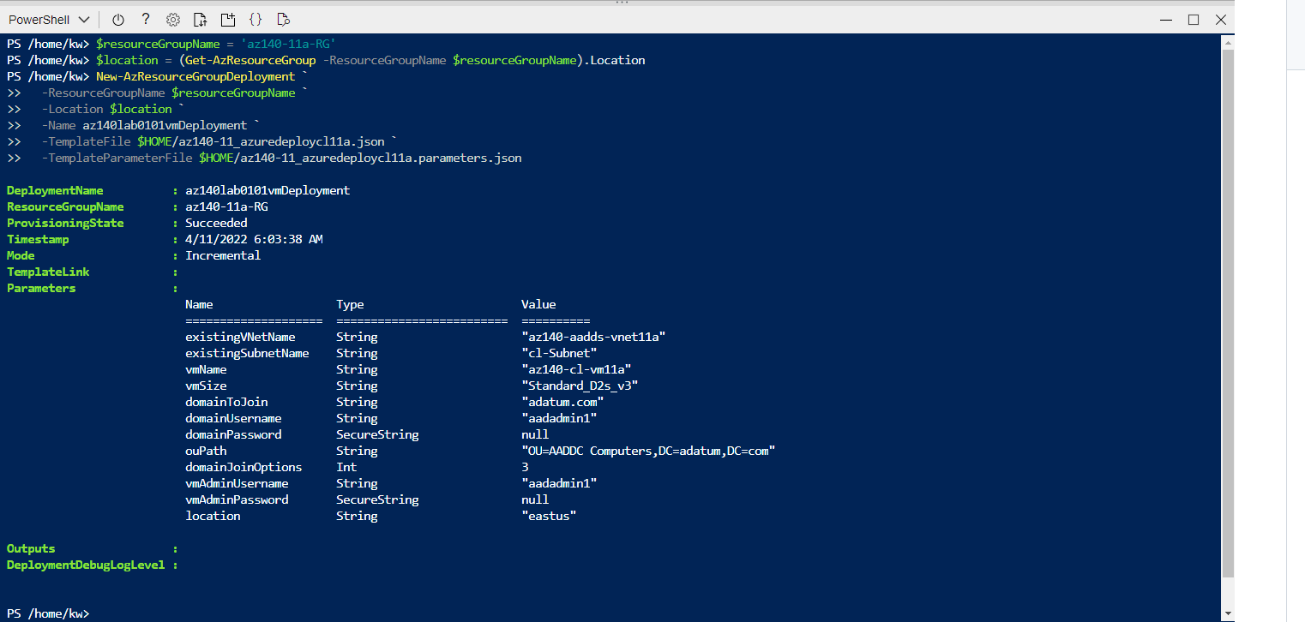

Note: The deployment might take about 10 minutes. Wait for the deployment to complete before you proceed to the next task.

### Task 2: Deploy Azure Bastion

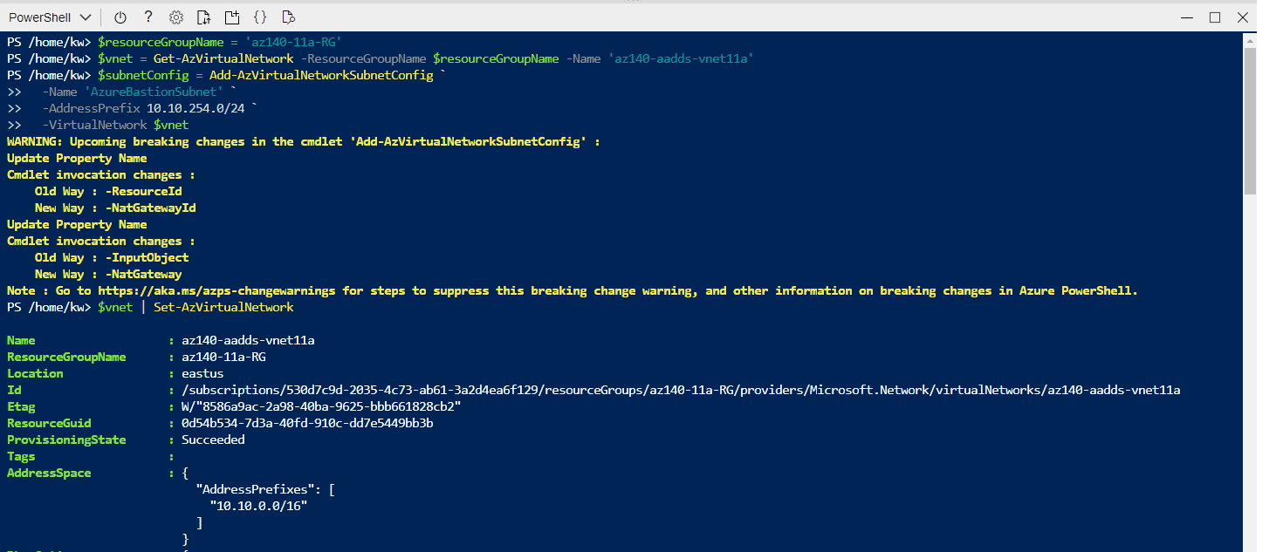

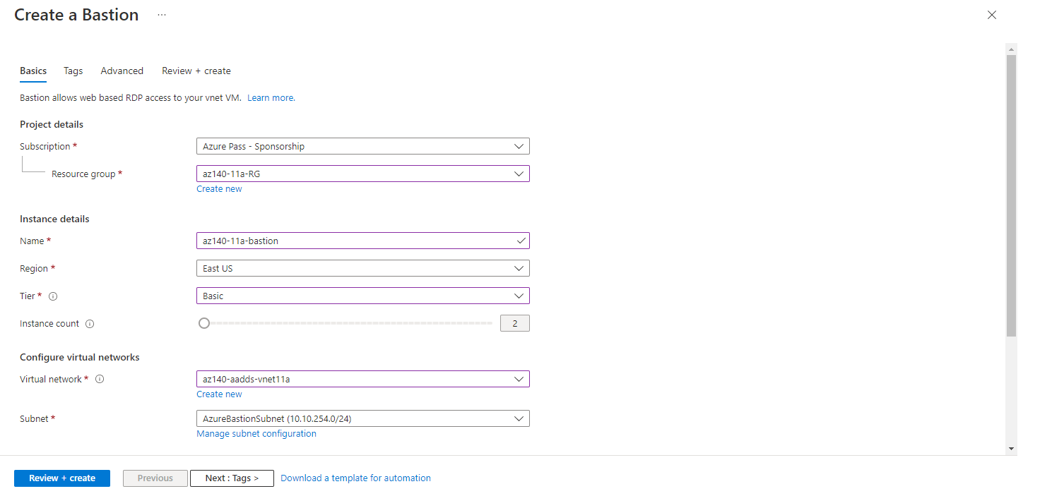

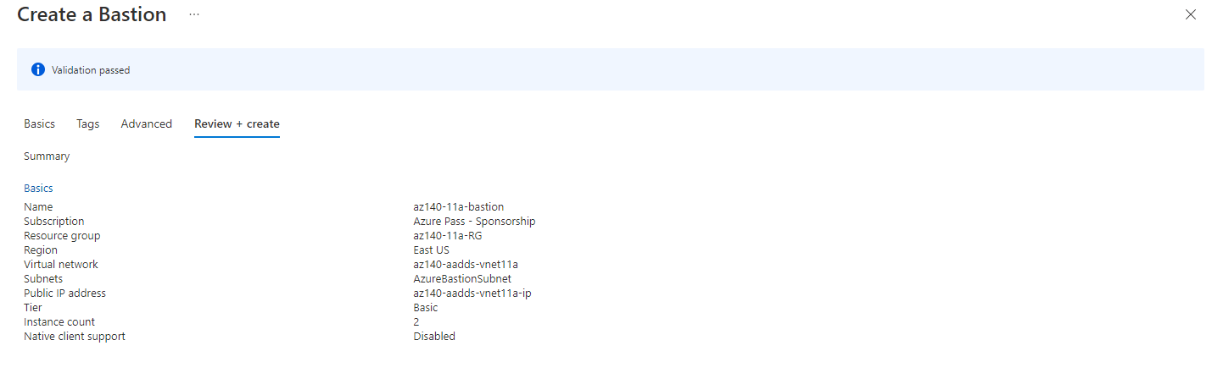

Note: Wait for the deployment to complete before you proceed to the next task of this exercise. The deployment might take about 5 minutes.

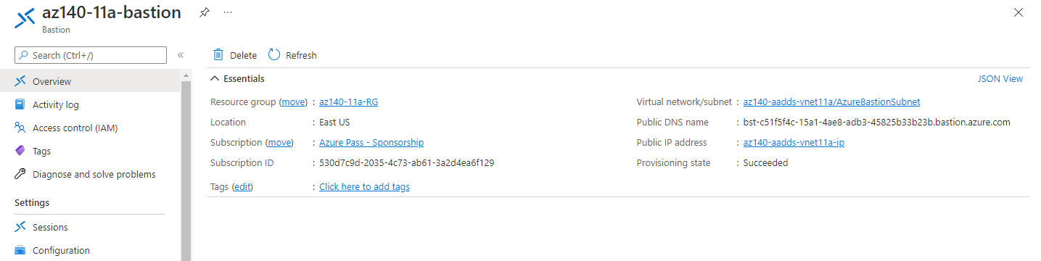

### Task 3: Review the default configuration of the Azure AD DS domain

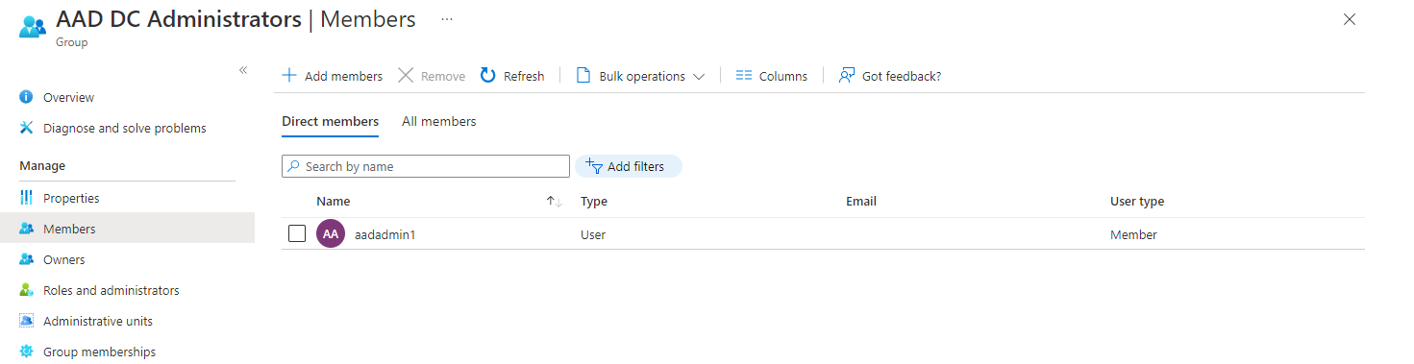

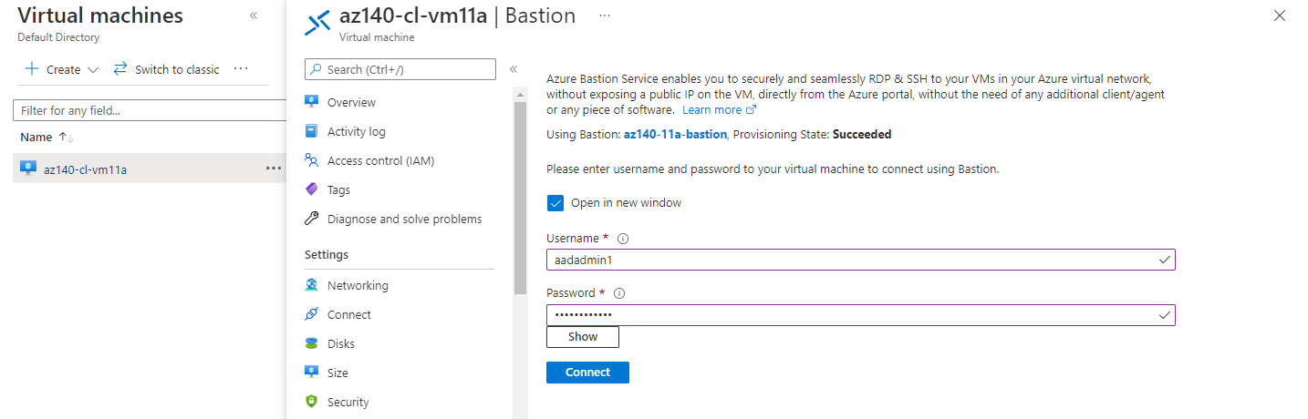

Login using [aadadmin1@KwNg100422outlook.onmicrosoft.com](mailto:aadadmin1@KwNg100422outlook.onmicrosoft.com) account and password: Pa55w.rd1234

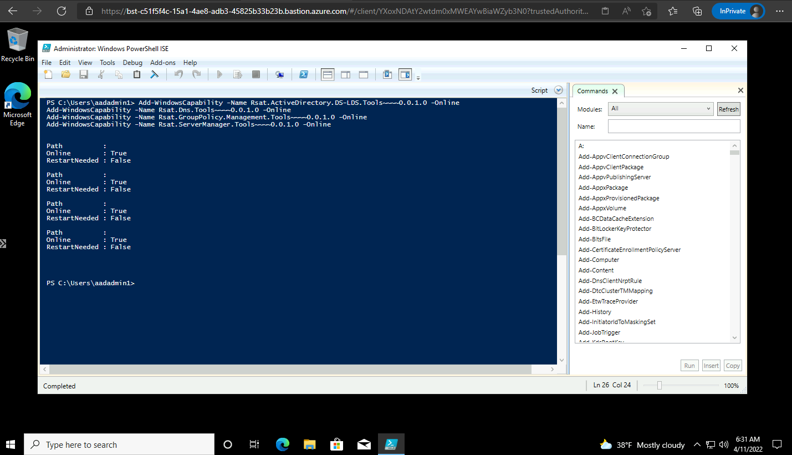

Note: Wait for the installation to complete before you proceed to the next step. This might take about 2 minutes

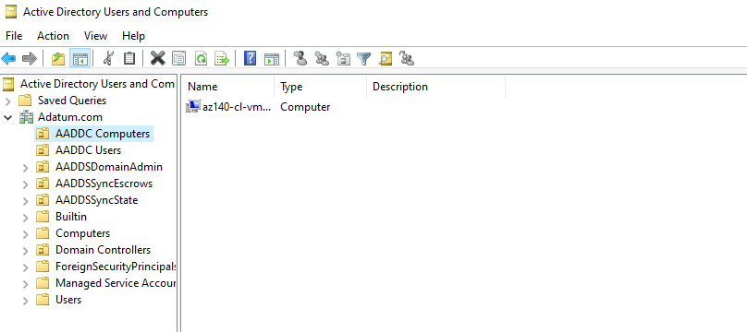

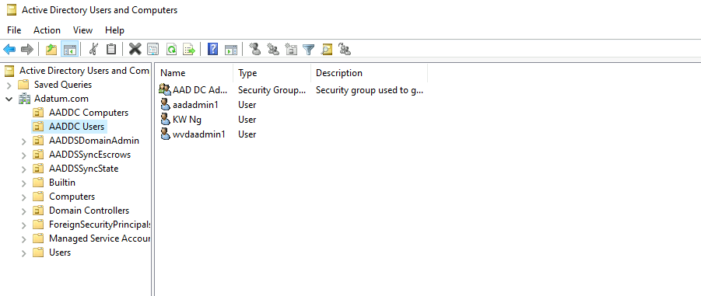

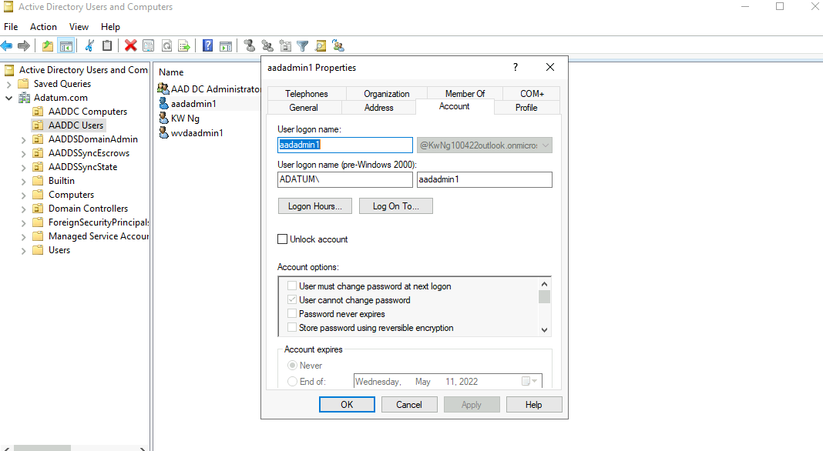

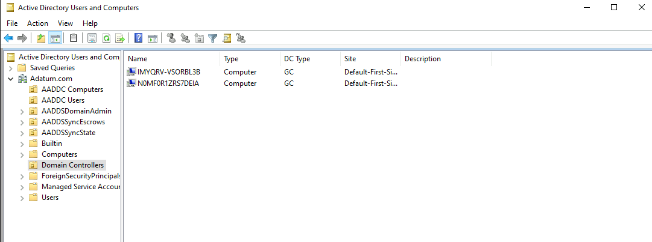

### Task 4: Create AD DS users and groups that will be synchronized to Azure AD DS

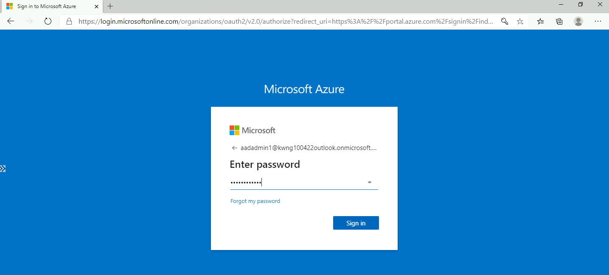

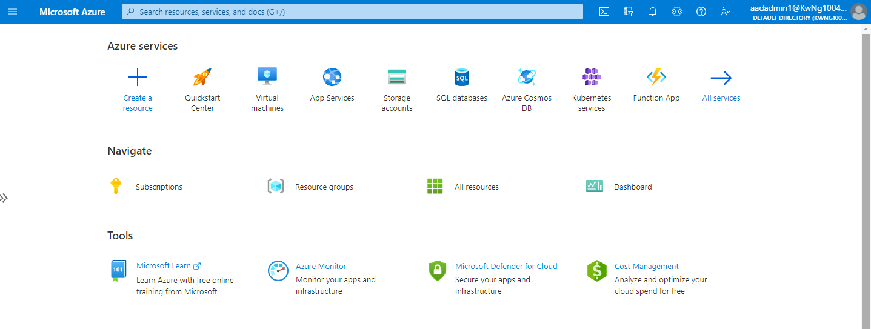

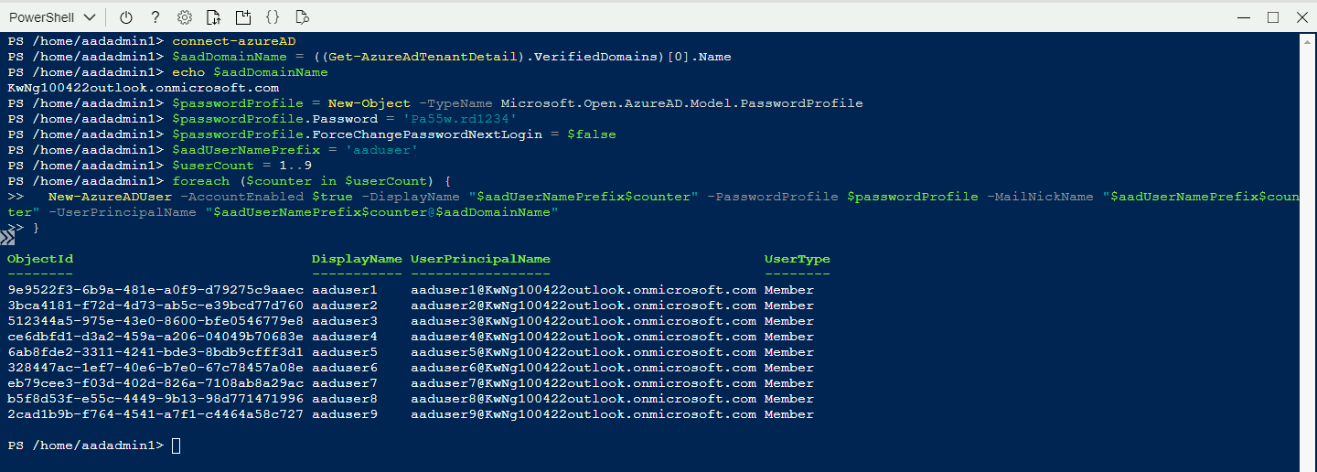

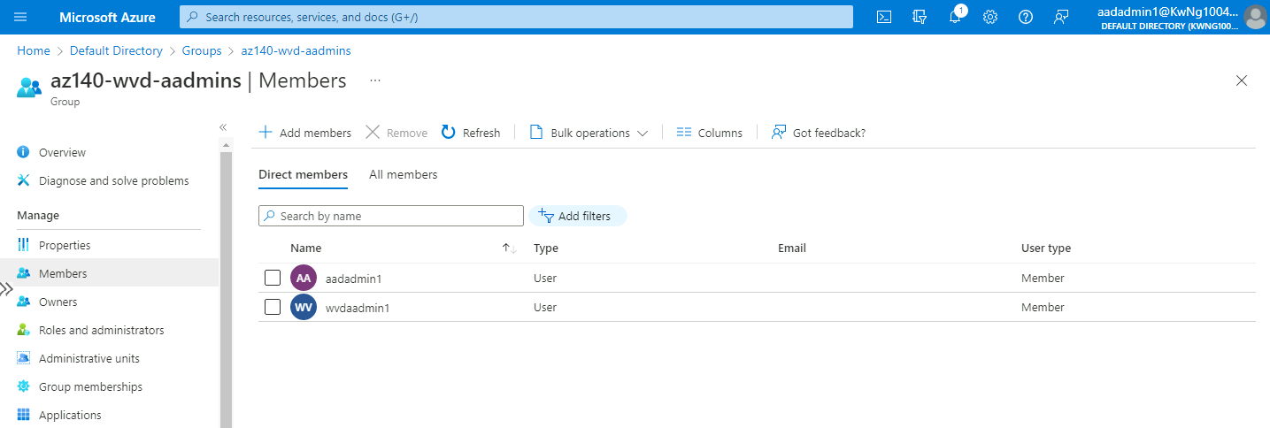

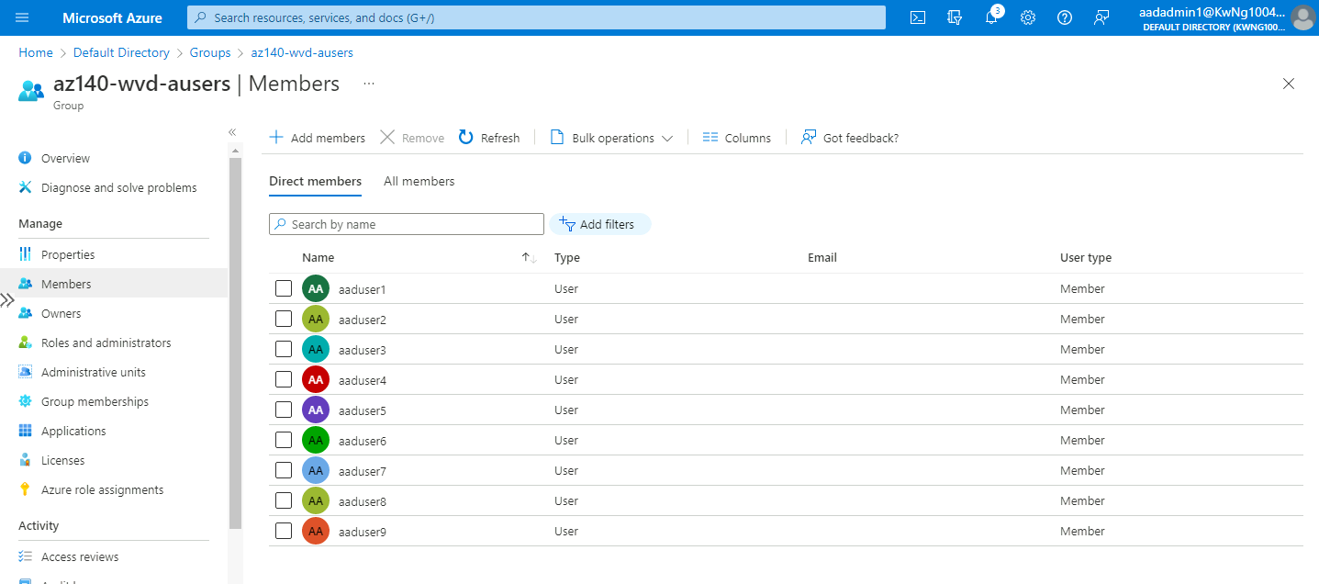

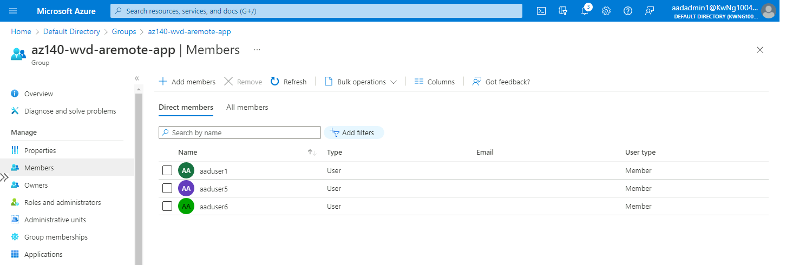

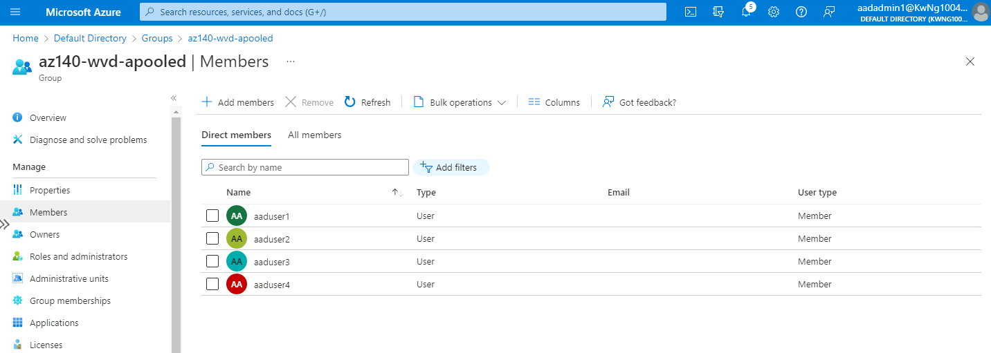

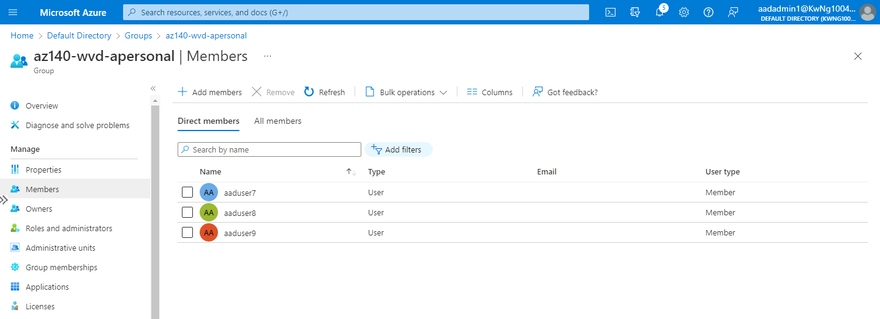

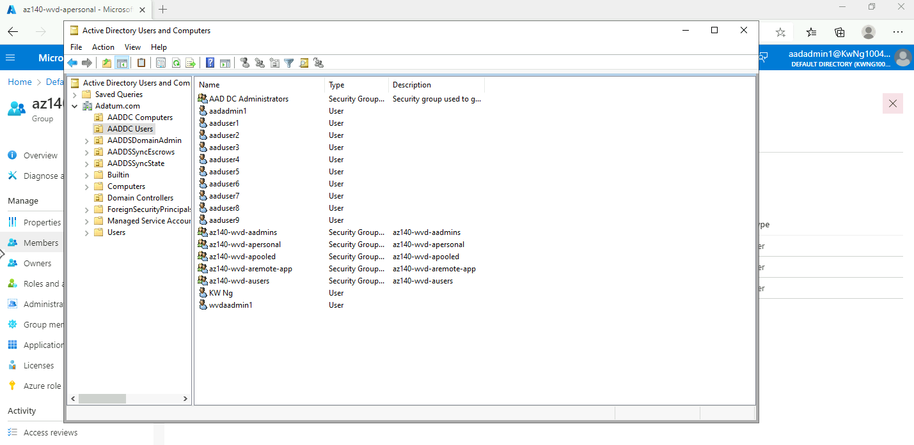

# Lab 02A - Create and configure host pools and session hosts (Azure AD DS)

## Exercise 1: Configure an Azure Virtual Desktop environment

### Task 1: Prepare AD DS domain and the Azure subscription for deployment of an Azure Virtual Desktop host pool

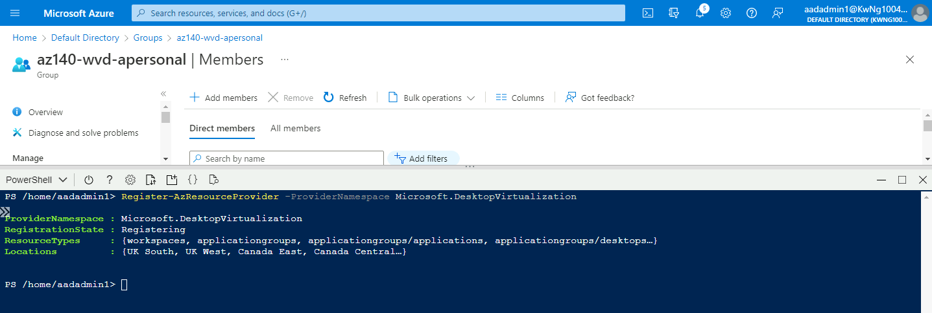

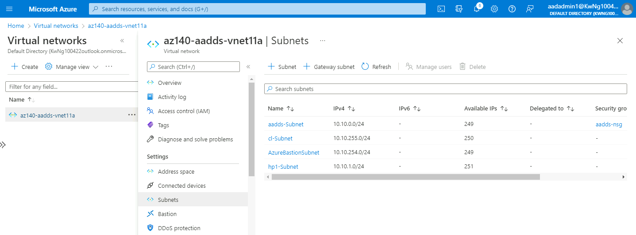

### Task 2: Deploy an Azure Virtual Desktop host pool

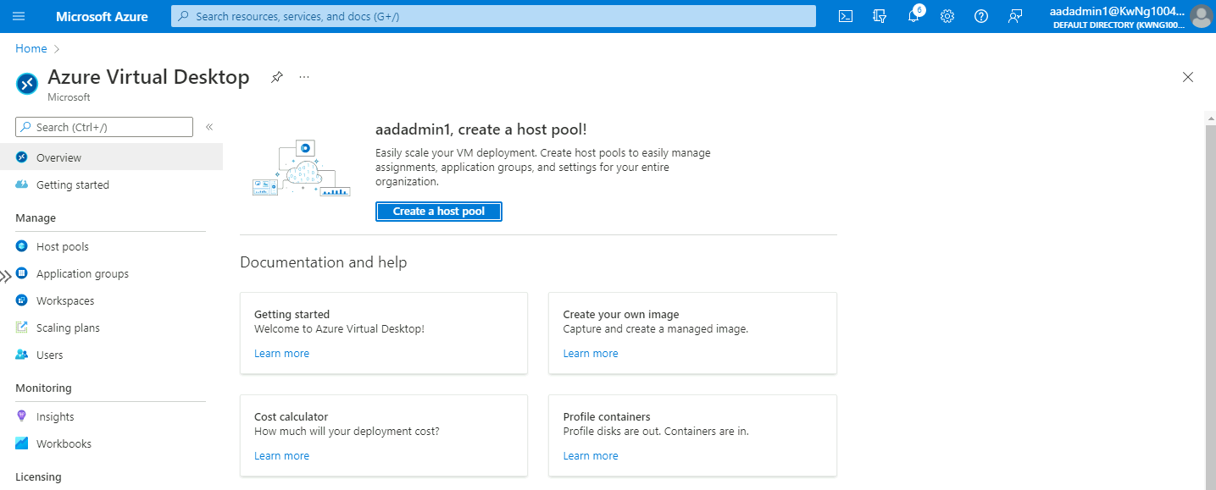

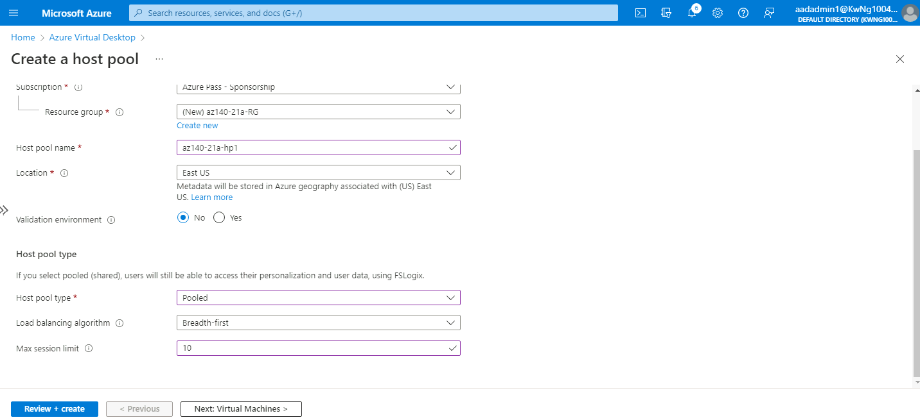

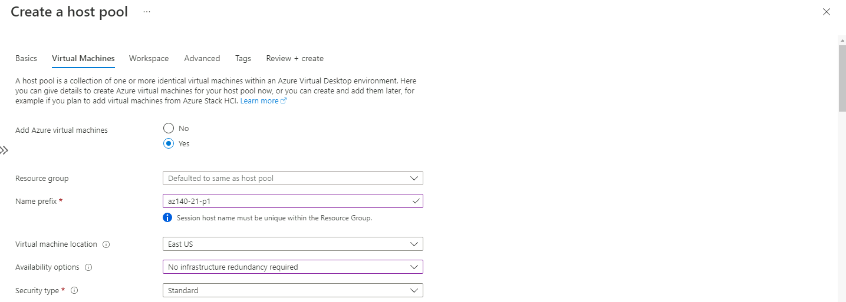

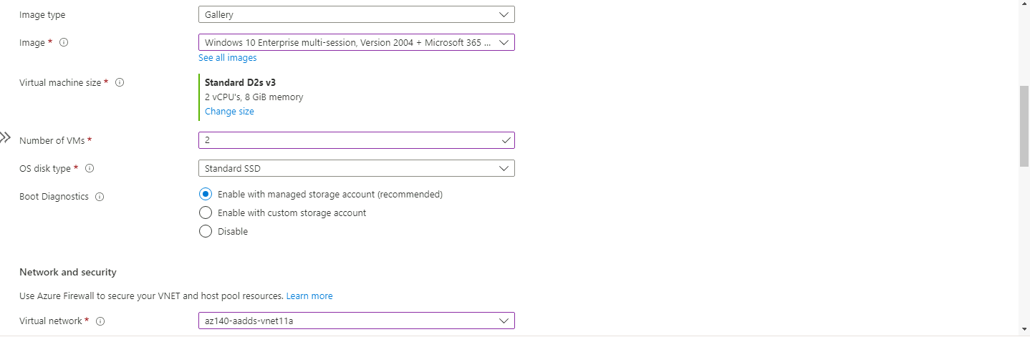

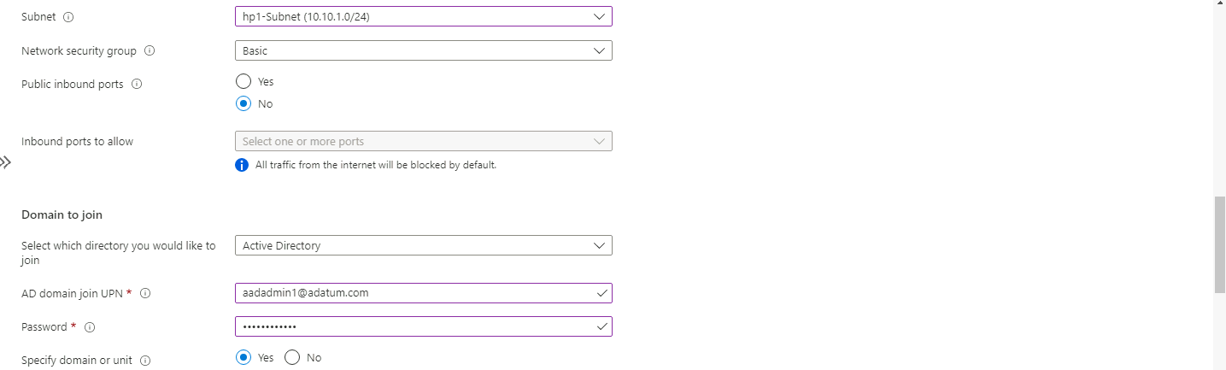

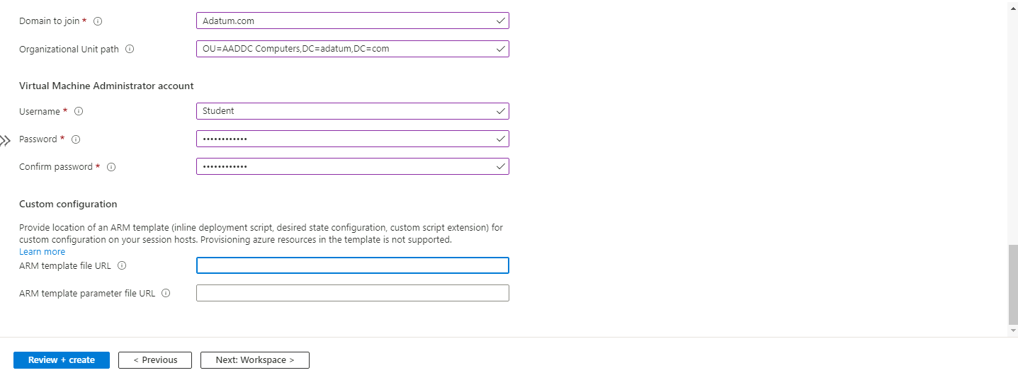

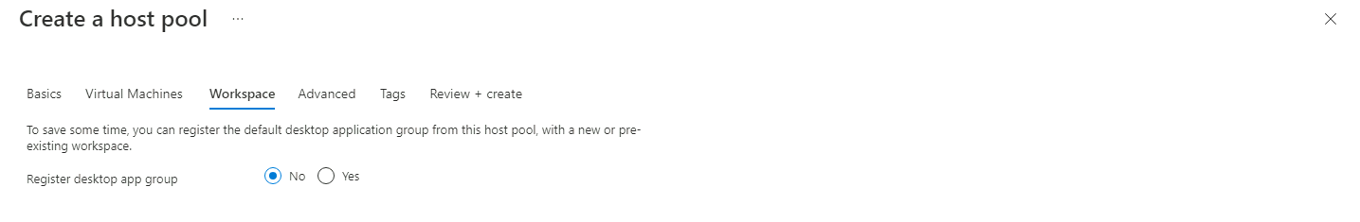

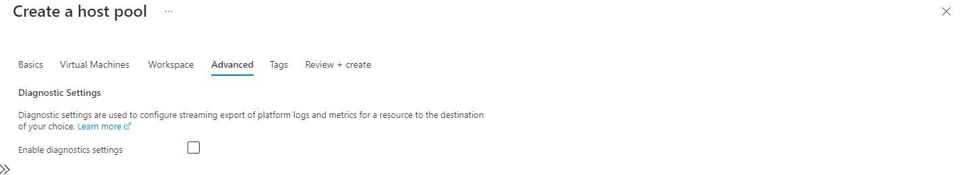

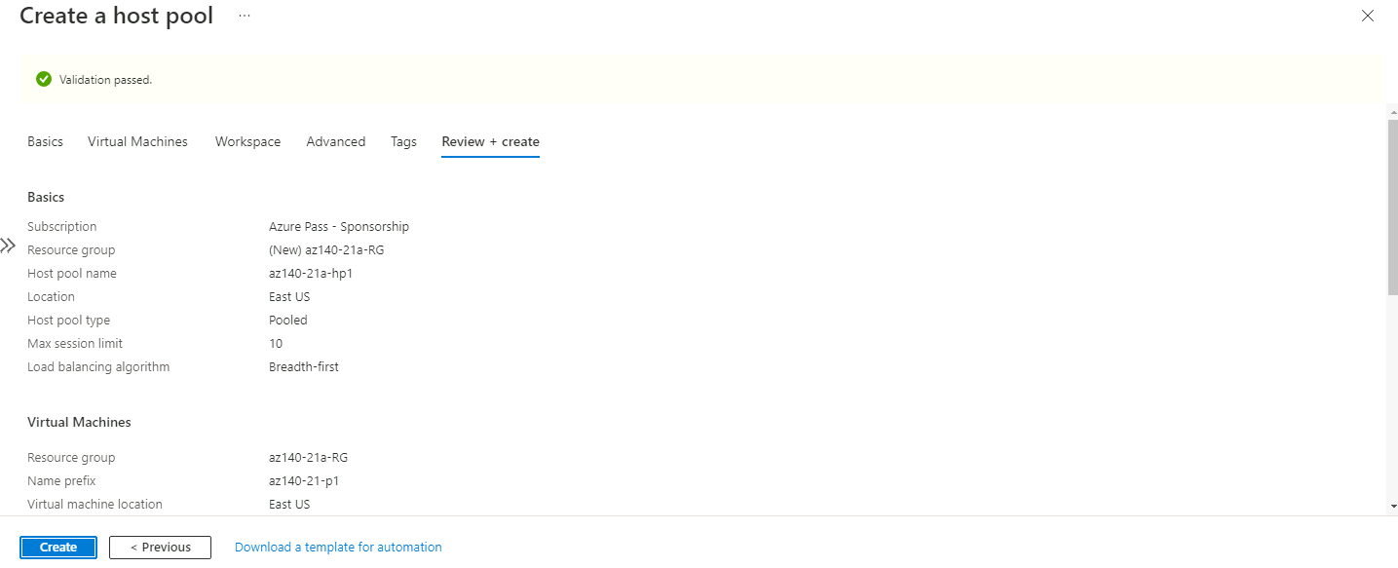

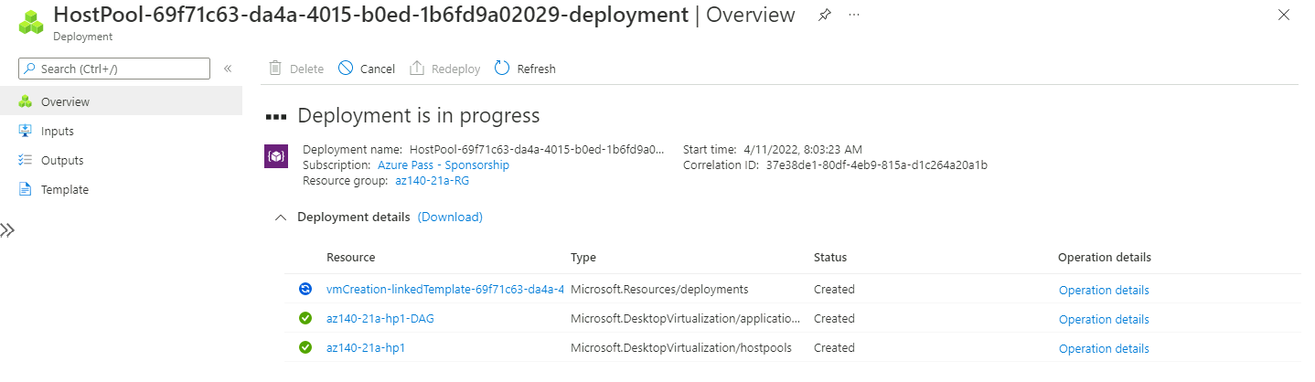

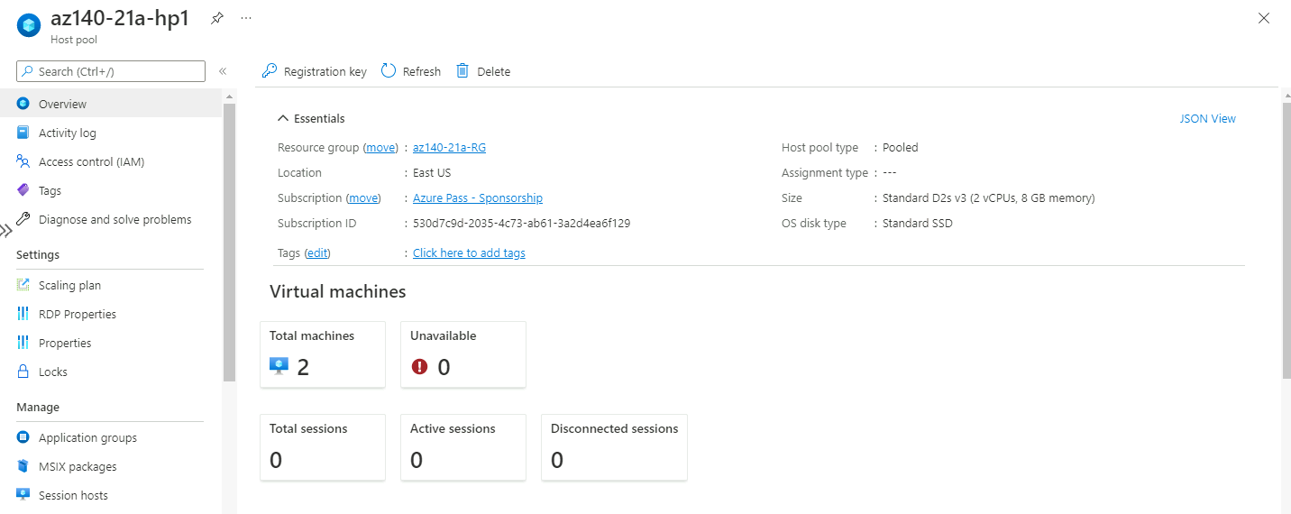

### Task 3: Configure Azure Virtual Desktop application groups

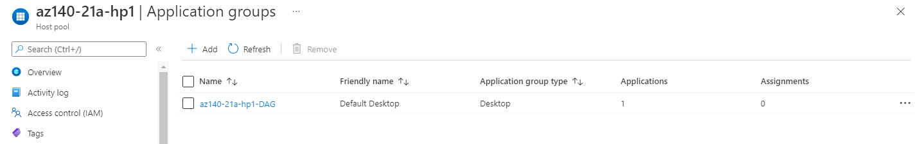

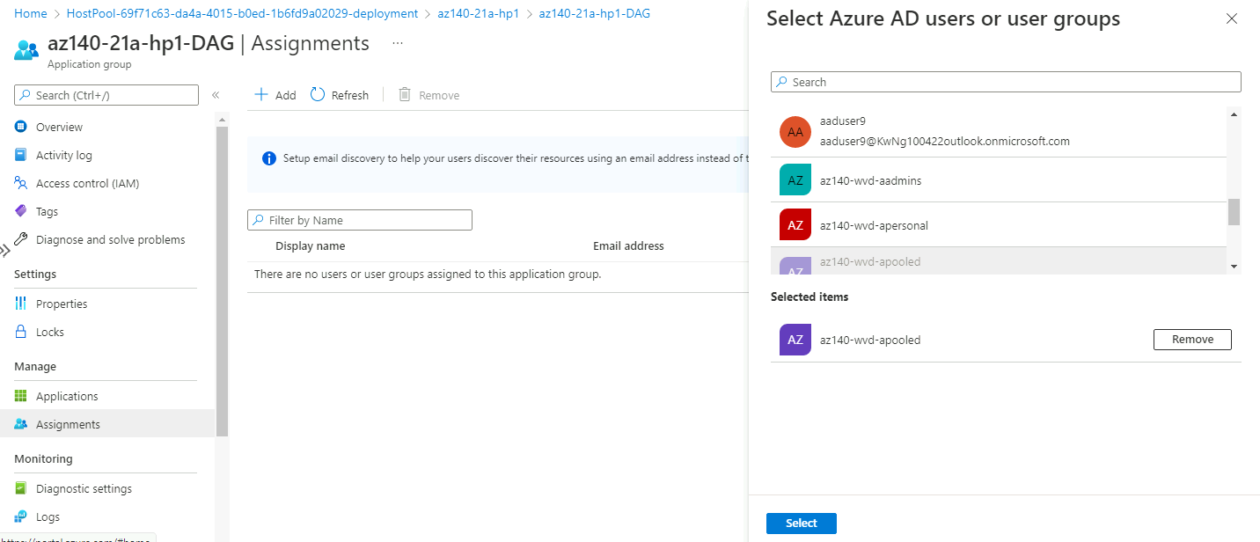

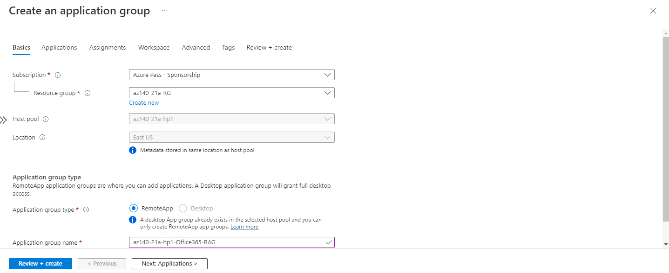

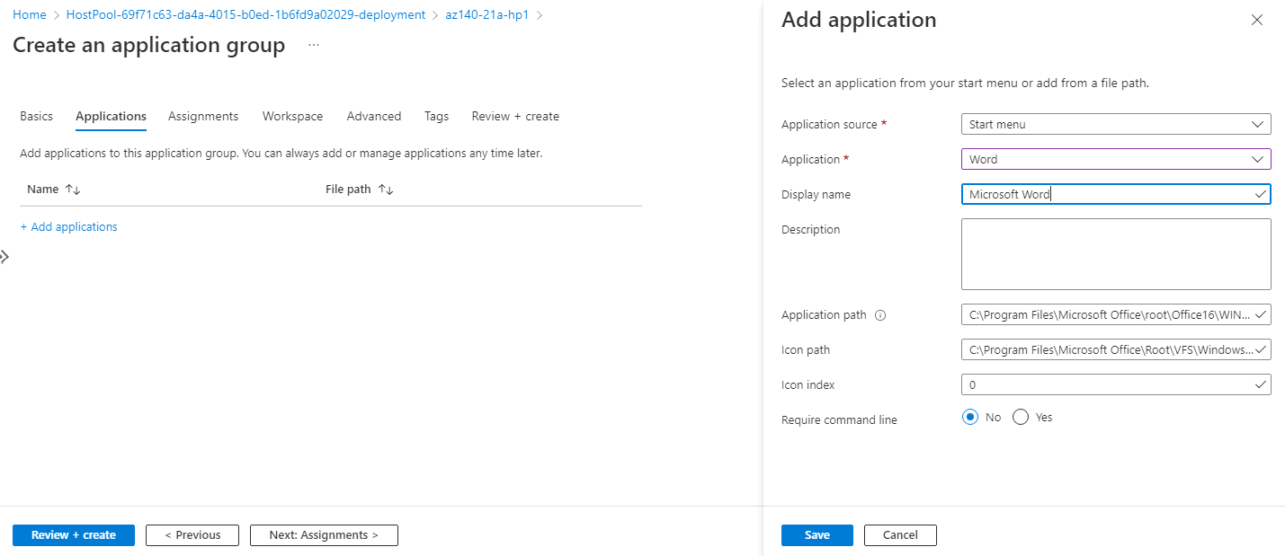

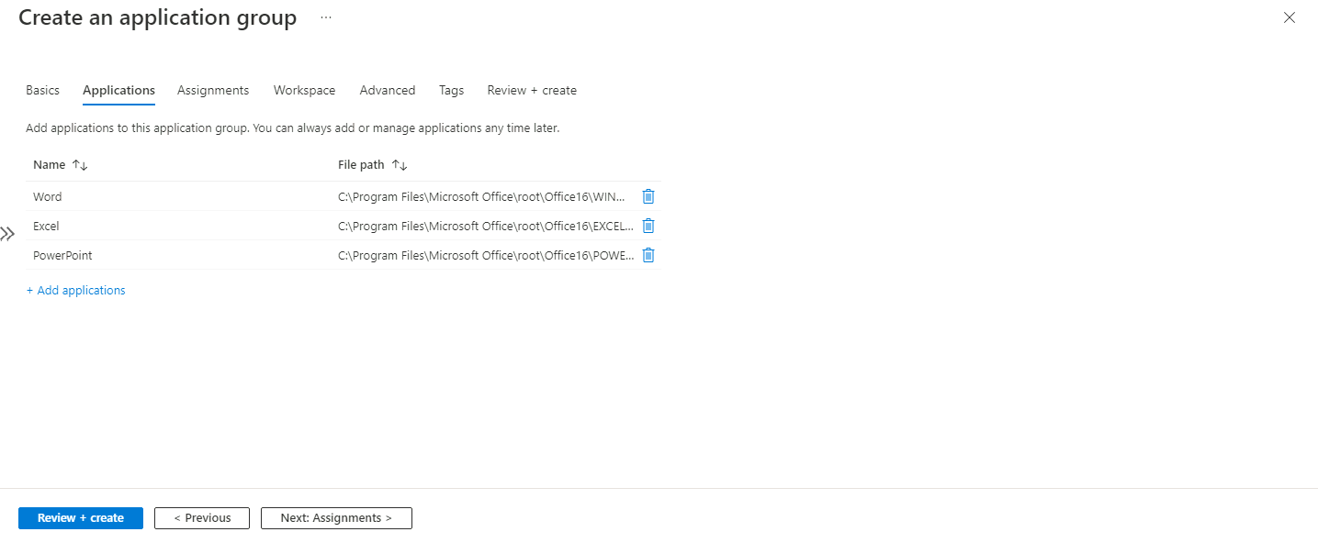

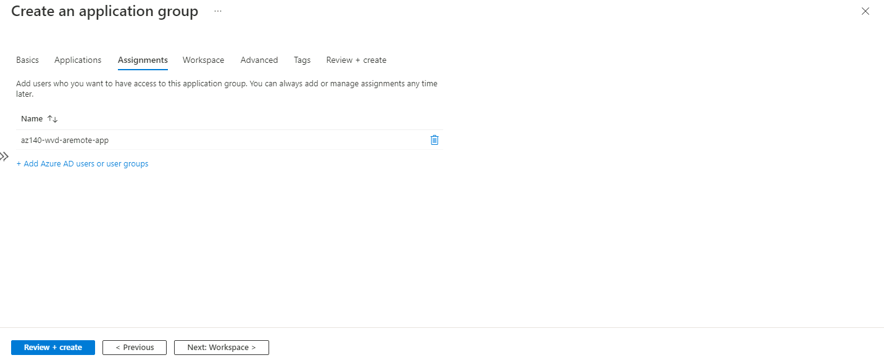

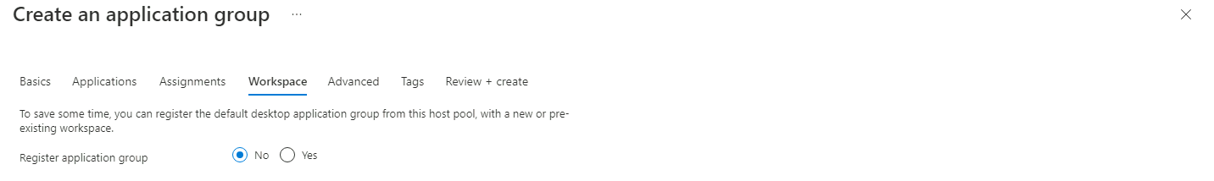

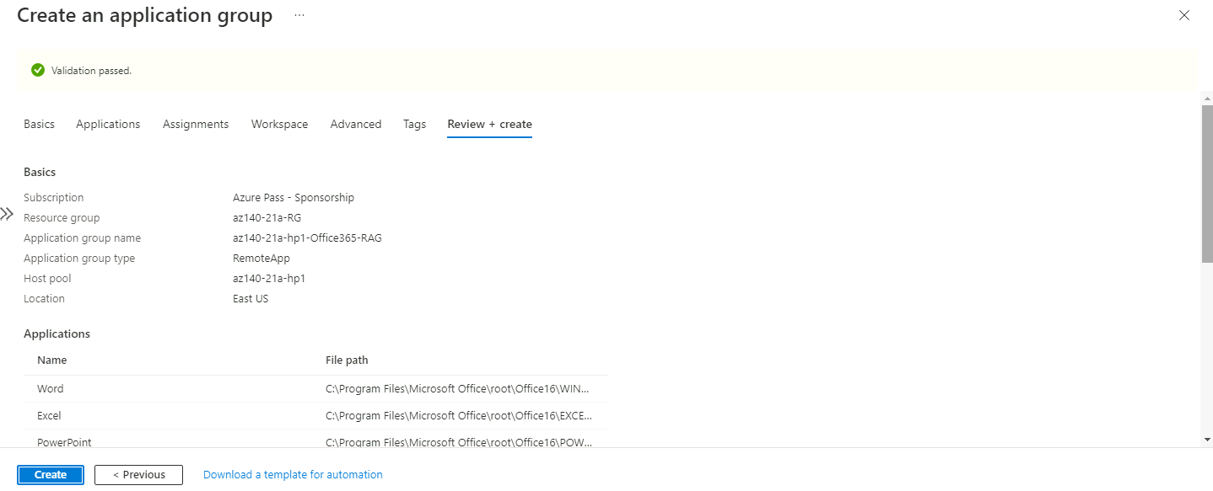

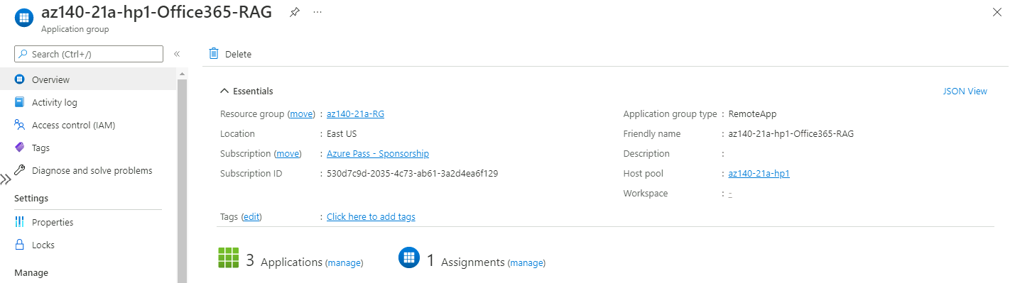

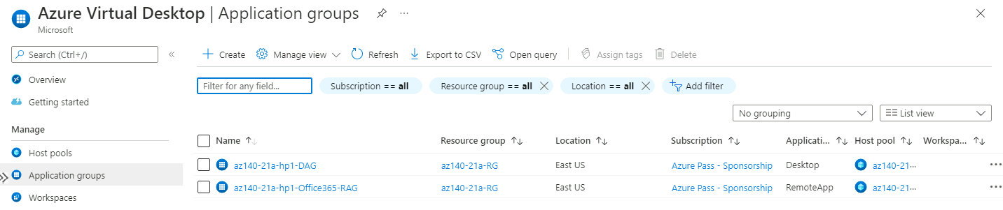

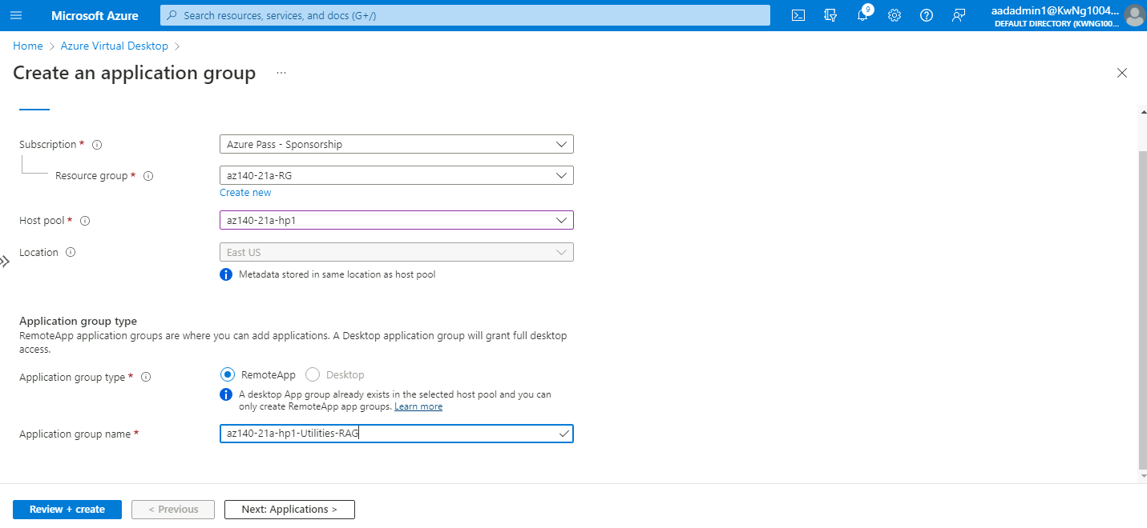

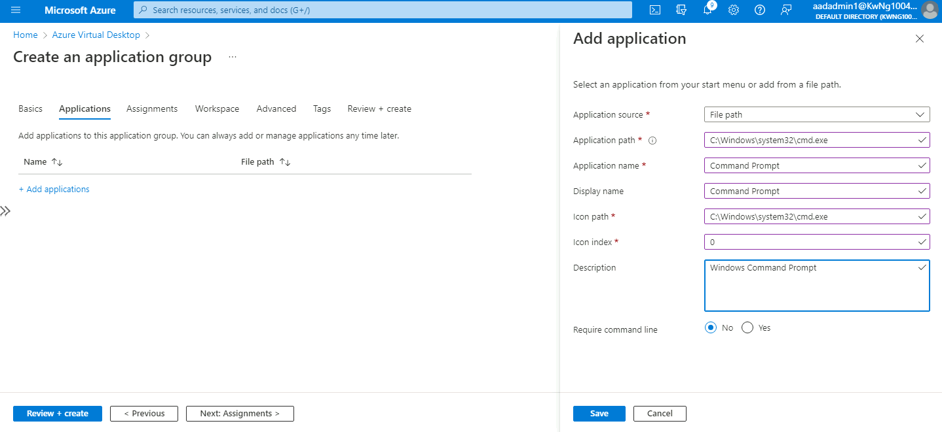

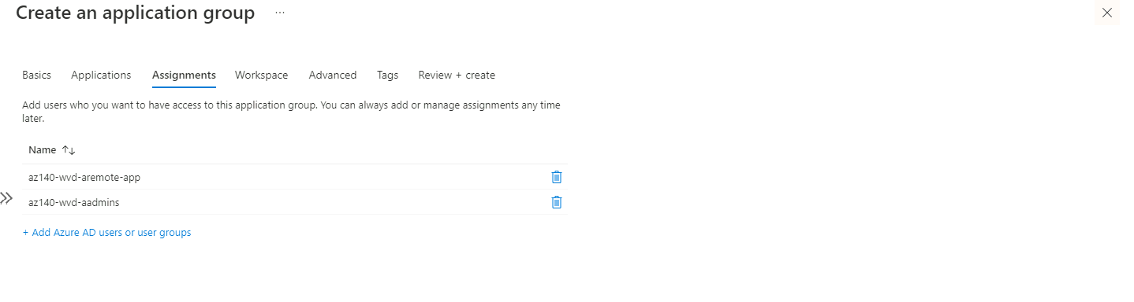

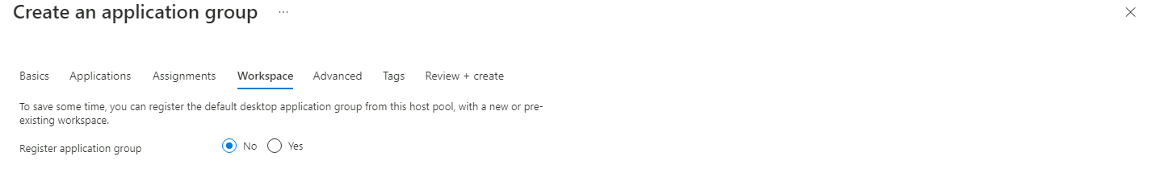

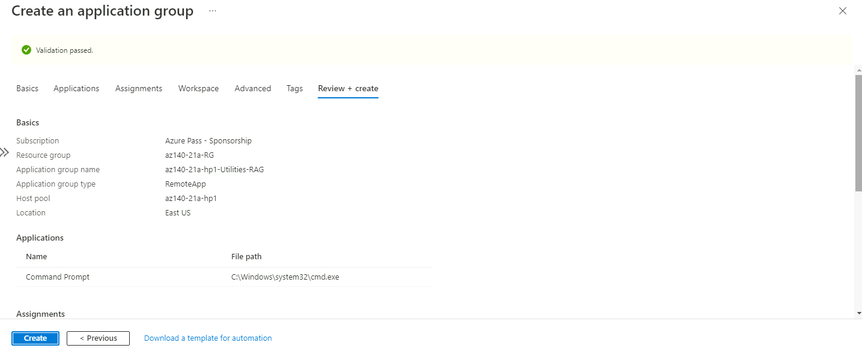

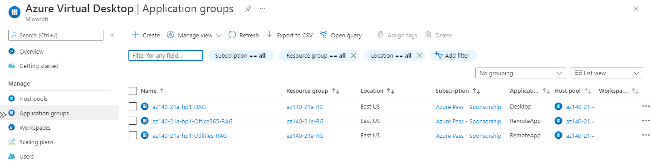

### Task 4: Configure Azure Virtual Desktop workspaces

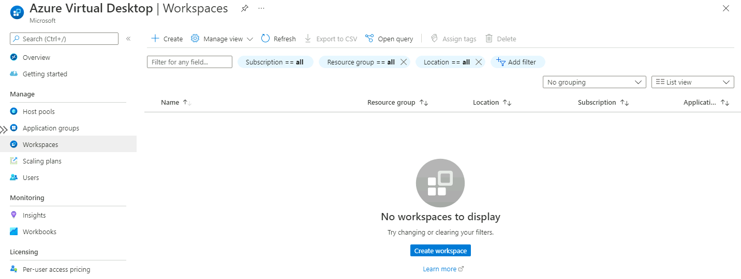

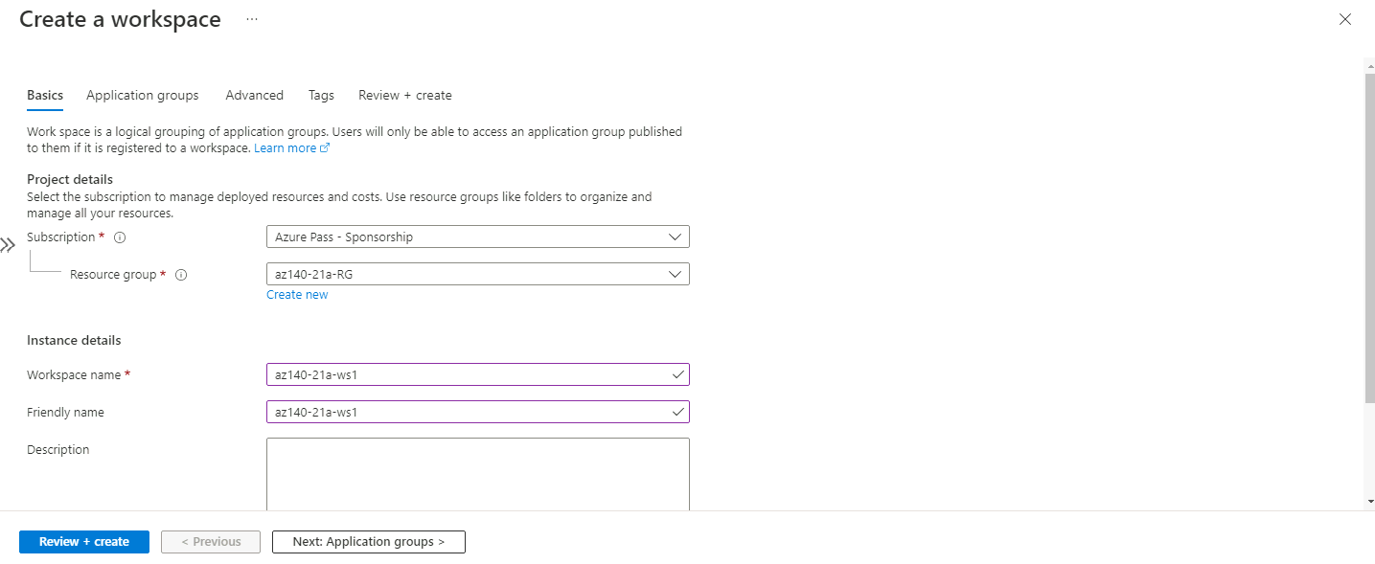

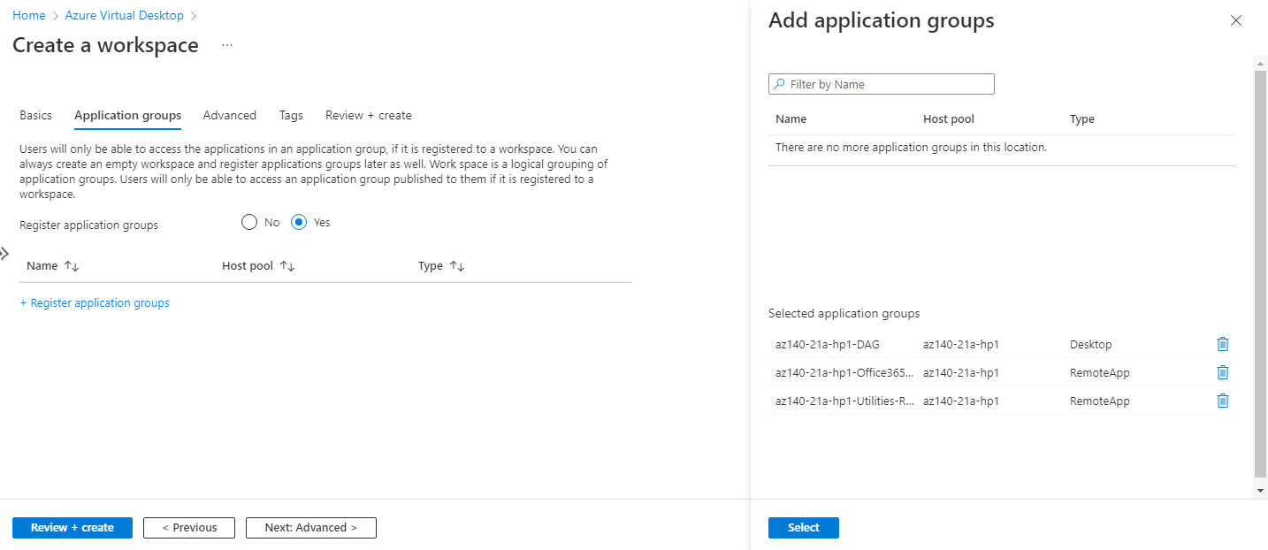

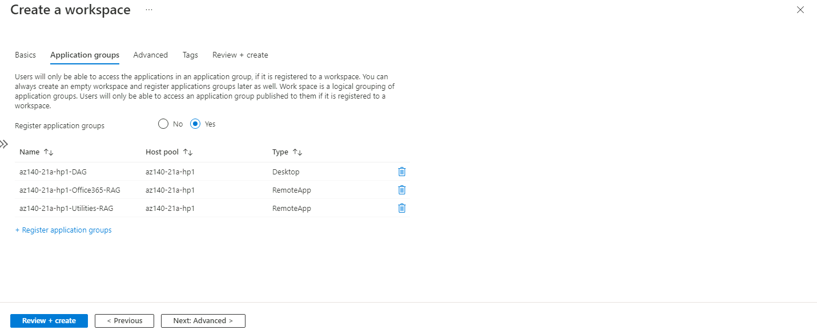

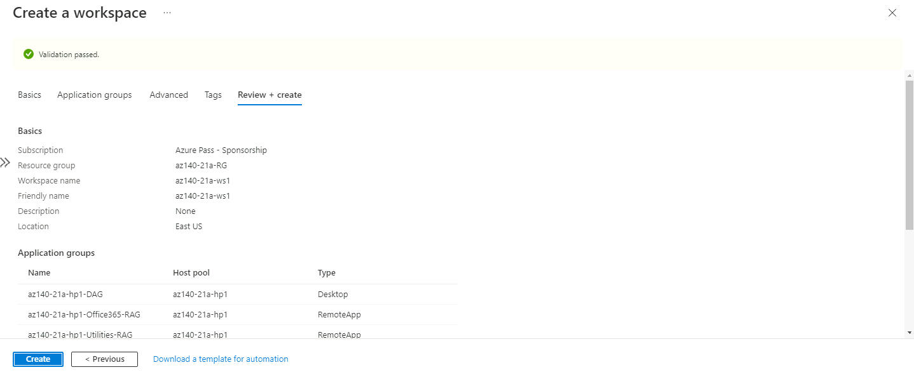

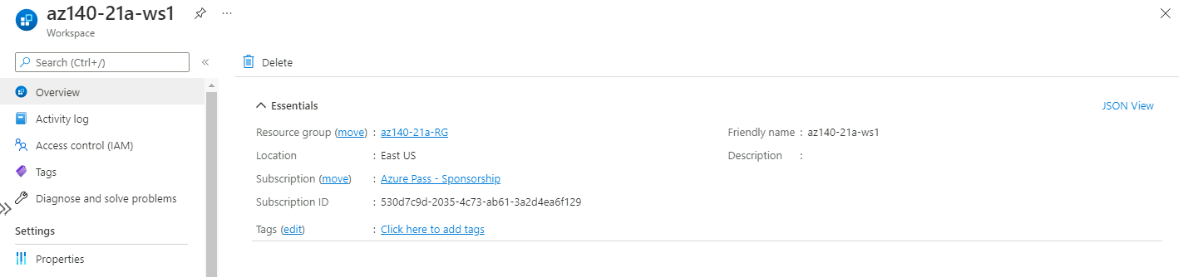

## Exercise 2: Validate Azure Virtual Desktop environment

### Task 1: Install Microsoft Remote Desktop client (MSRDC) on a Windows 10 computer

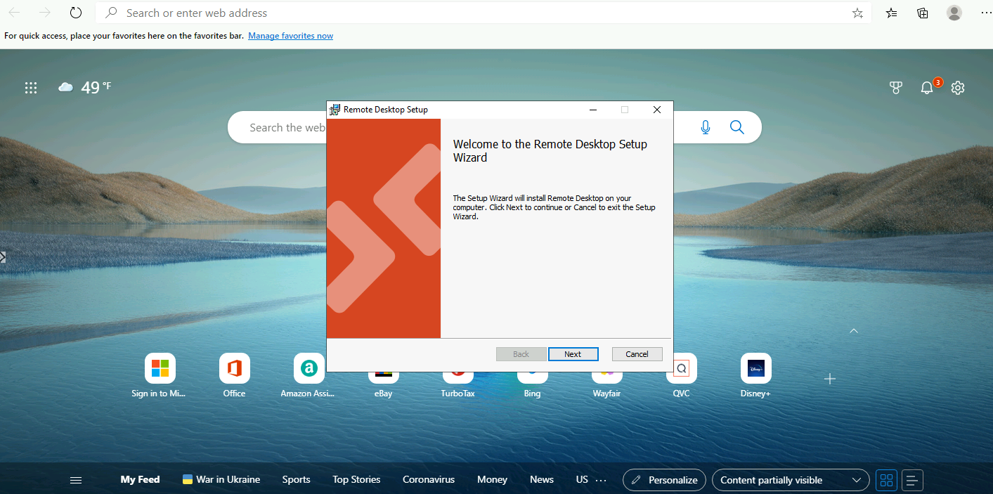

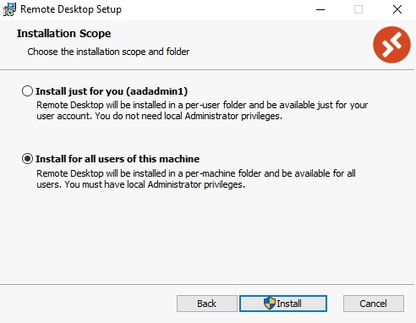 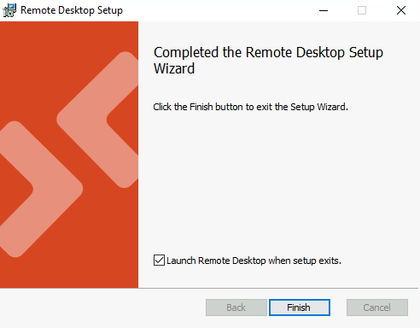

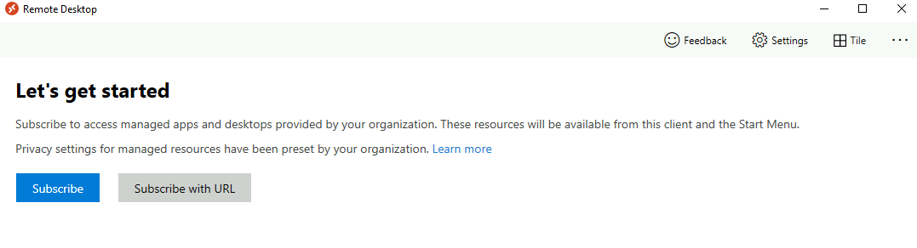

### Task 2: Subscribe to a Azure Virtual Desktop workspace

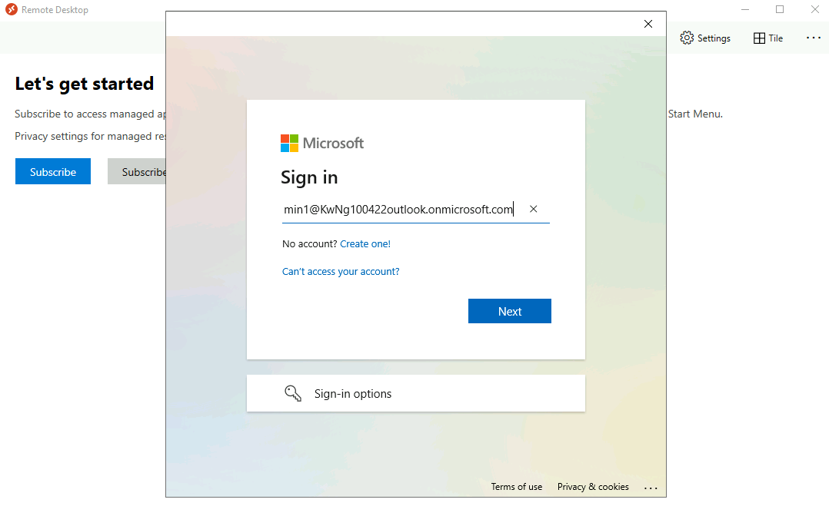

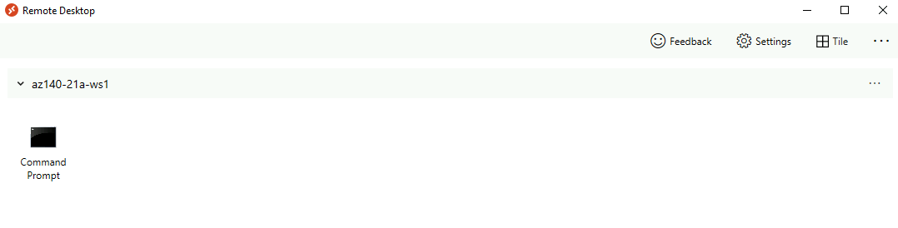

#Login into Remote Desktop using [aadadmin1@KwNg100422outlook.onmicrosoft.com](mailto:aadadmin1@KwNg100422outlook.onmicrosoft.com) credential

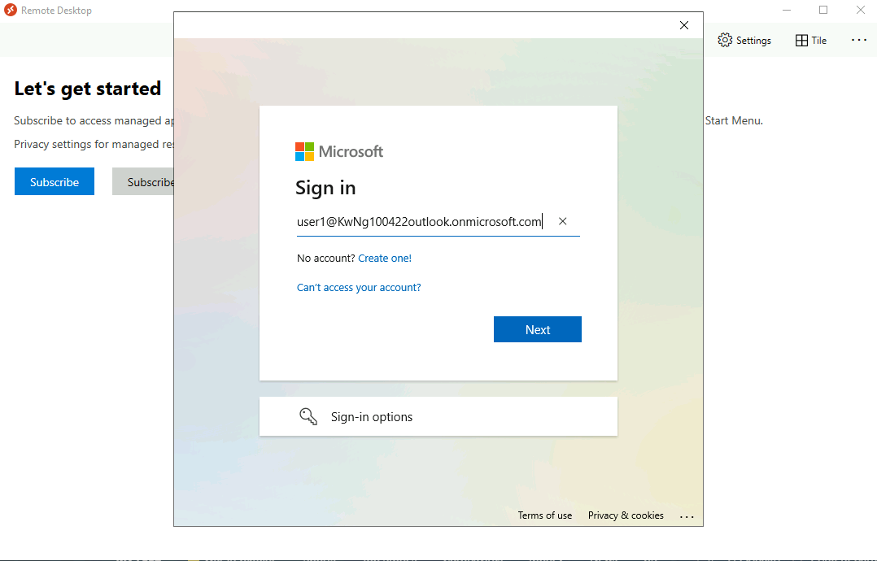

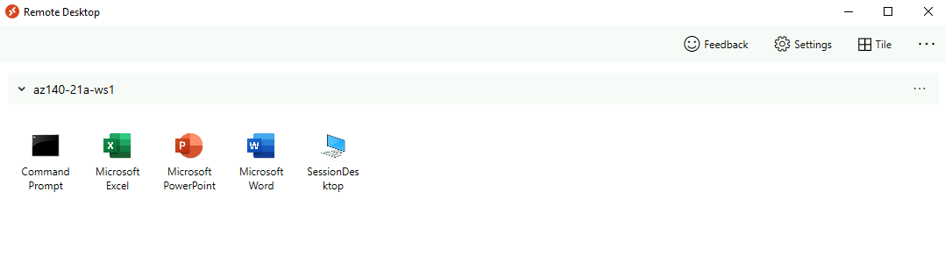

#Login into Remote Desktop using aaduser1@KwNg100422outlook.onmicrosoft.com credential

### Task 3: Test Azure Virtual Desktop apps

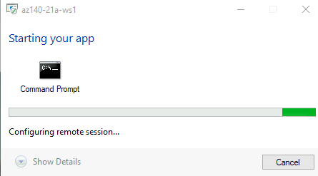 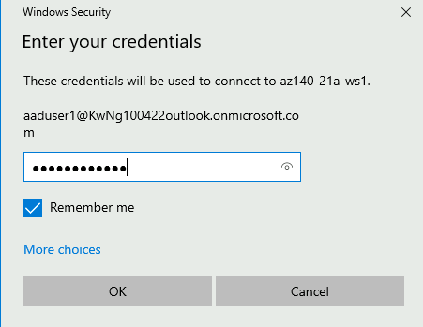

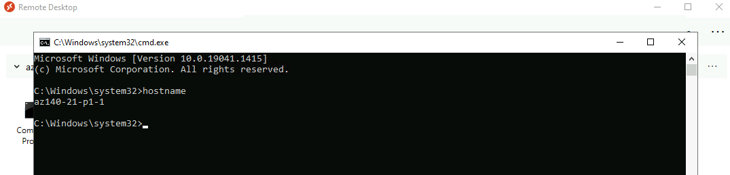

Note: Verify that the displayed name is either az140-21-p1-0 or az140-21-p1-1, not az140-cl-vm11a

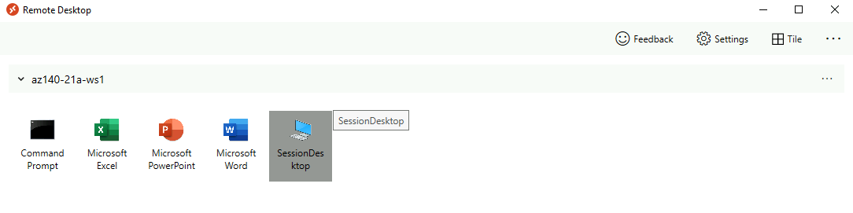

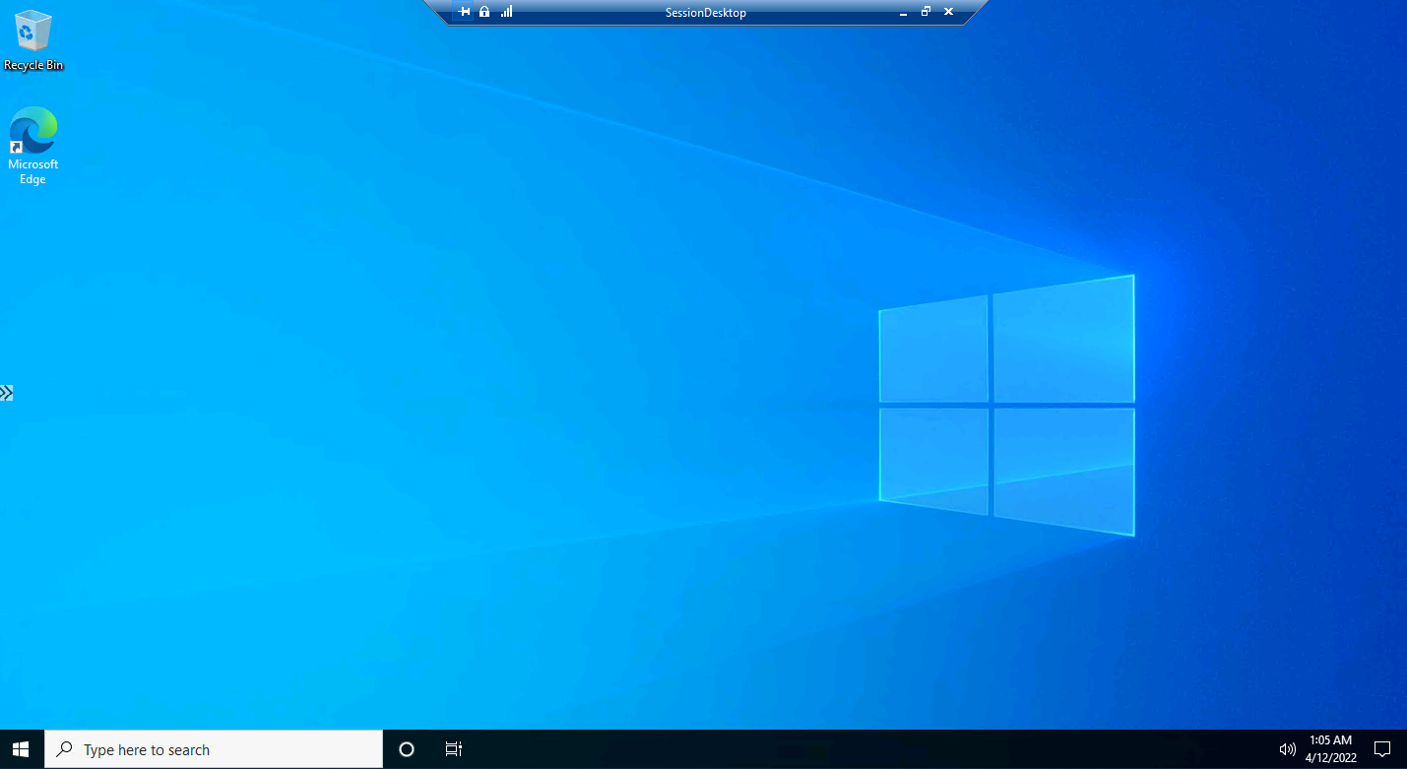

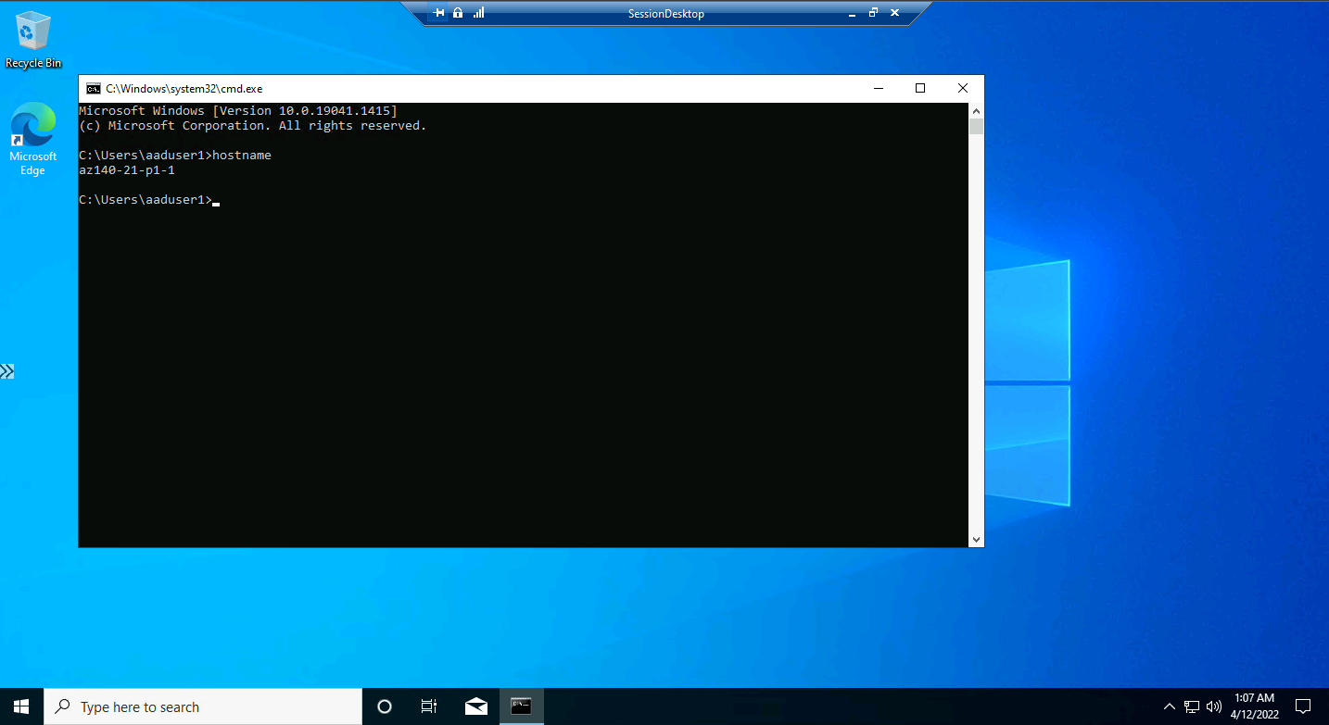

Verify that the displayed name is either az140-21-p1-0, az140-21-p1-1 or az140-21-p1-2

# Lab 02B - Implement and manage storage for AVD (Azure AD DS)

## Exercise 1: Configure Azure Files to store profile containers for Azure Virtual Desktop

### Task 1: Create an Azure Storage account

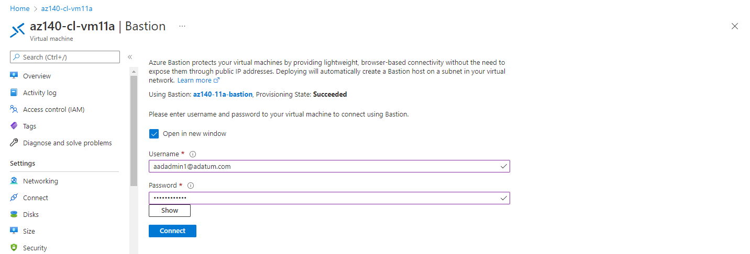

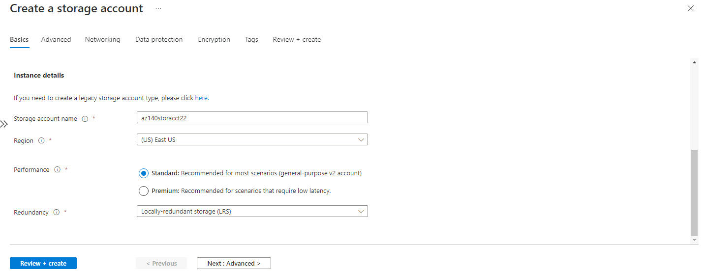

Note: Make sure that the length of the storage account name does not exceed 15 characters. The name will be used to create a computer account in the Active Directory Domain Services (AD DS) domain that is integrated with the Azure AD tenant associated with the Azure subscription containing the storage account. This will allow for AD DS-based authentication when accessing file shares hosted in this storage account

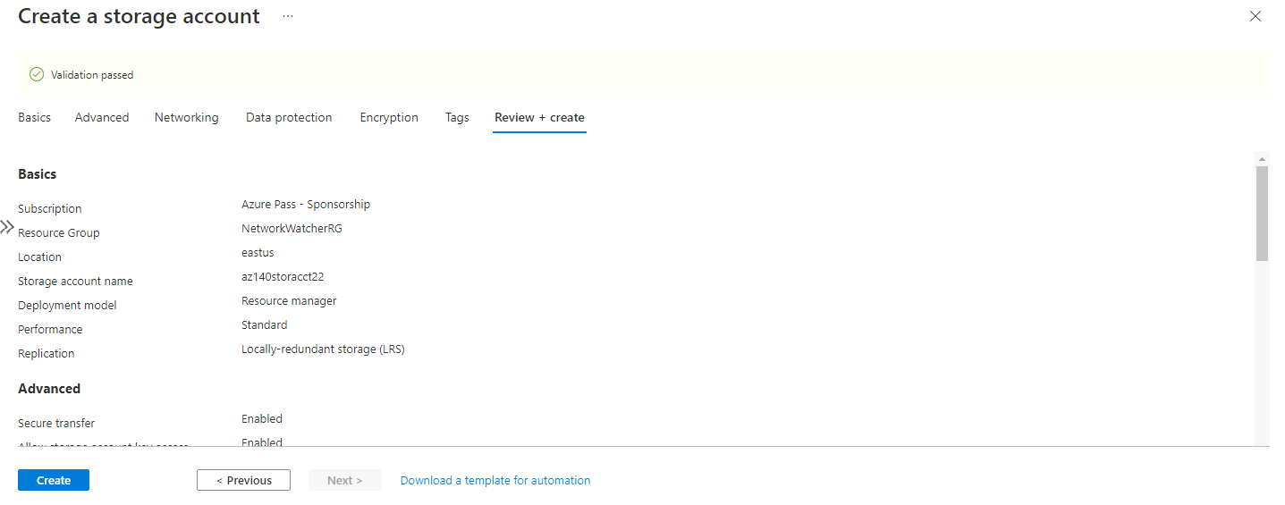

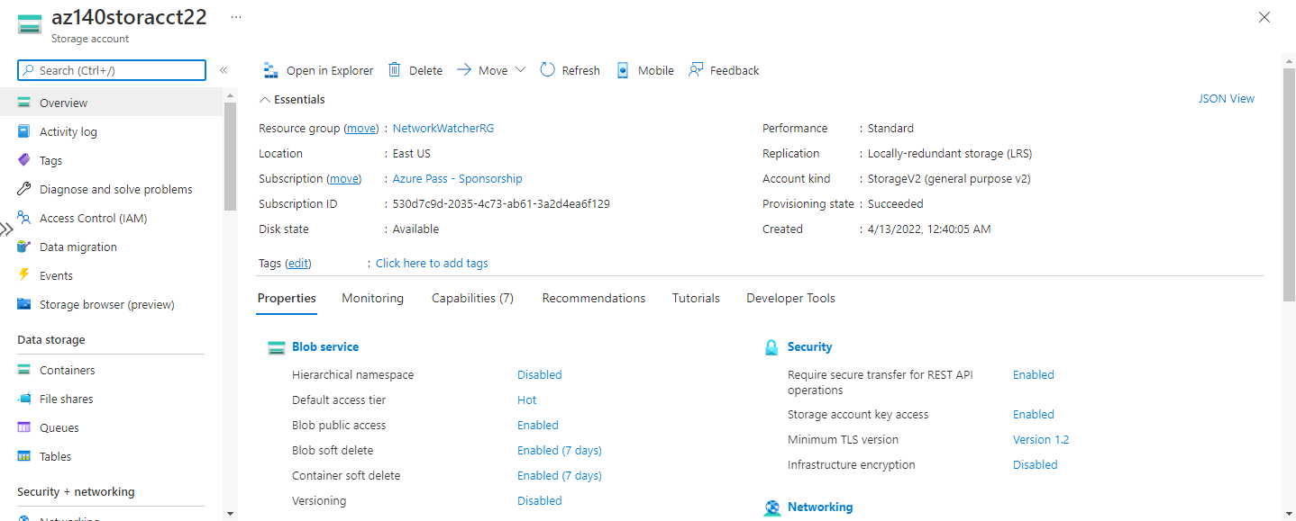

### Task 2: Create an Azure Files share

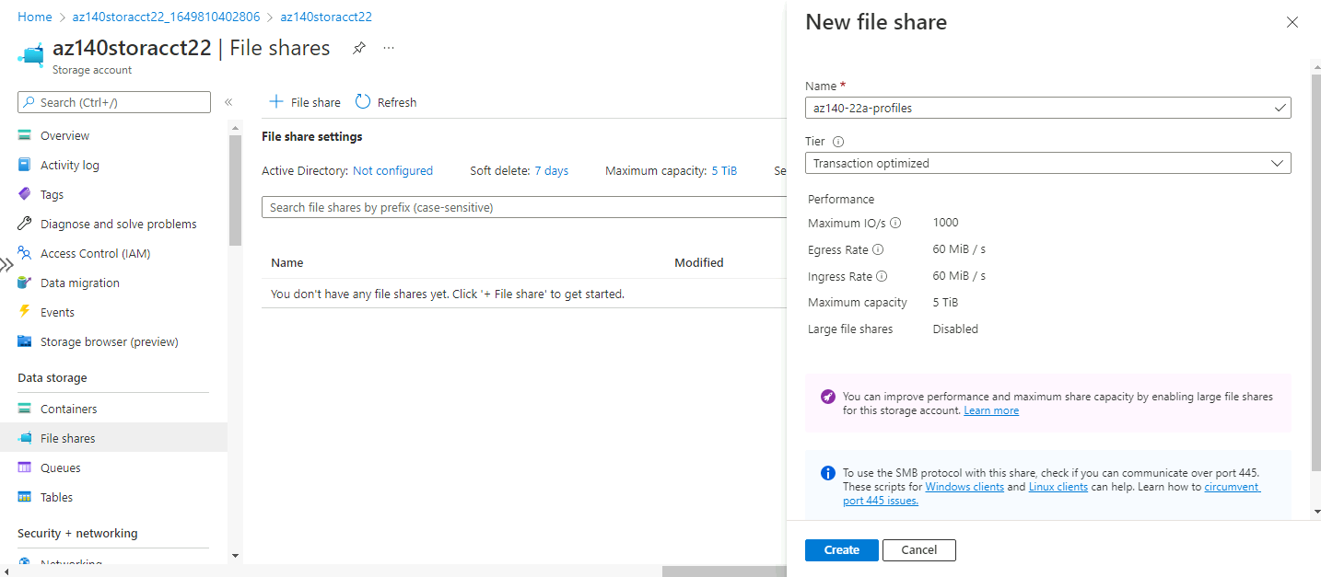

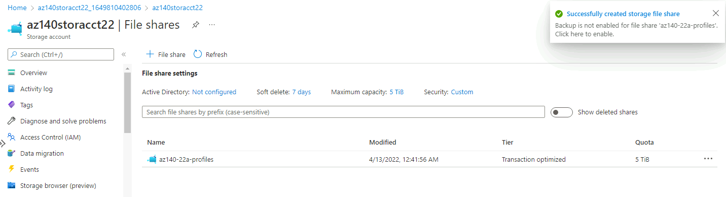

### Task 3: Enable Azure AD DS authentication for the Azure Storage account

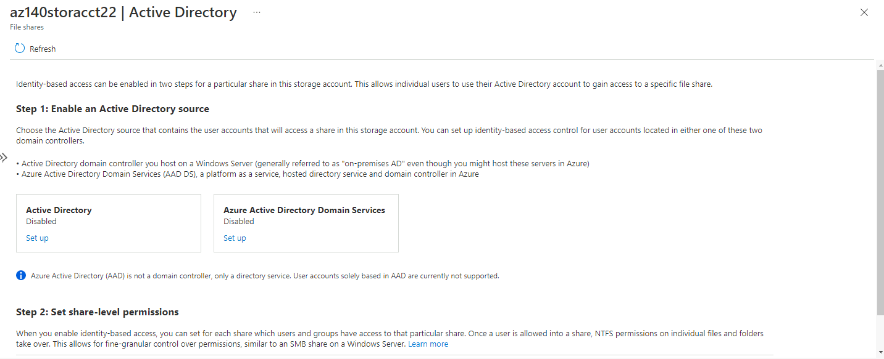

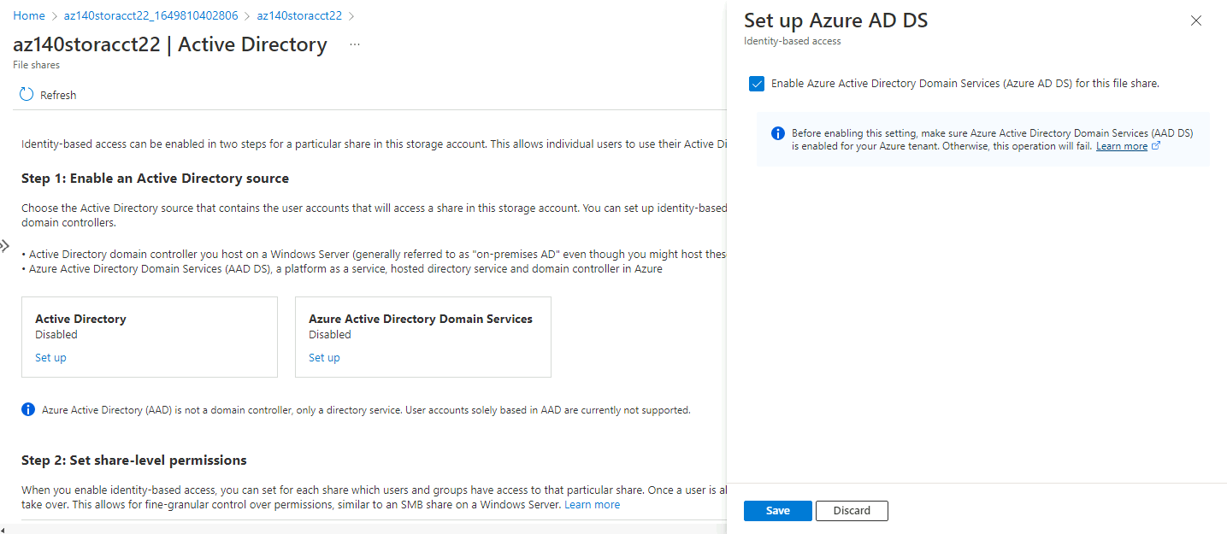

### Task 4: Configure the Azure Files RBAC-based permissions

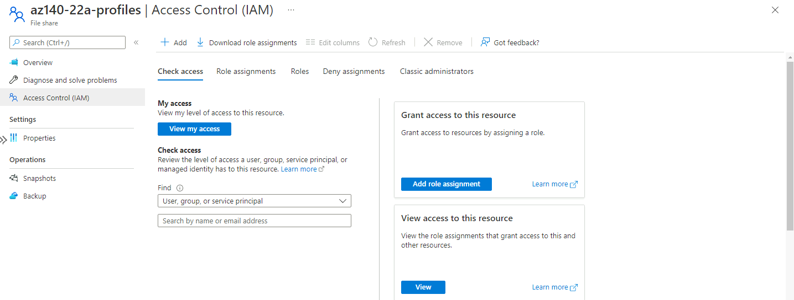

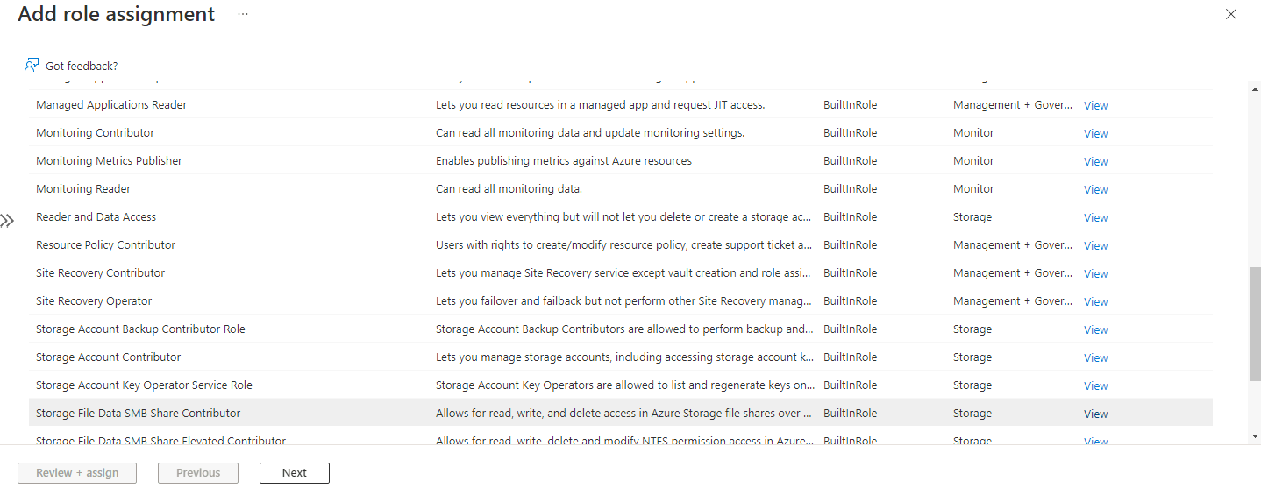

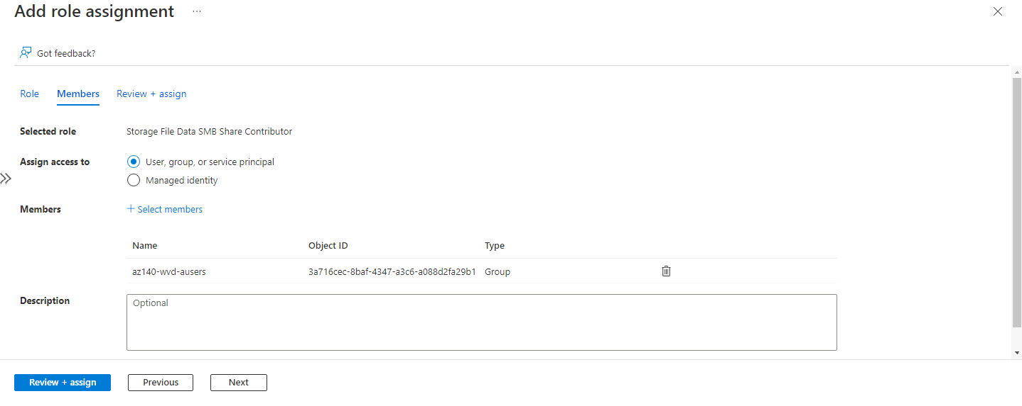

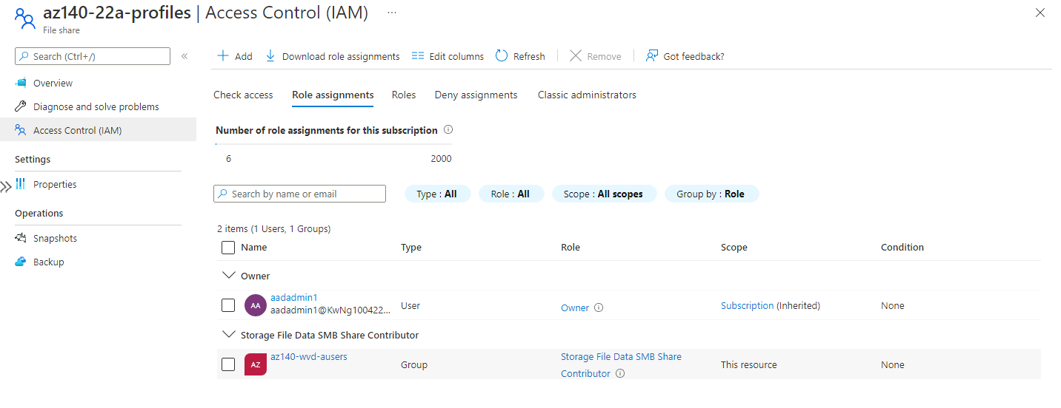

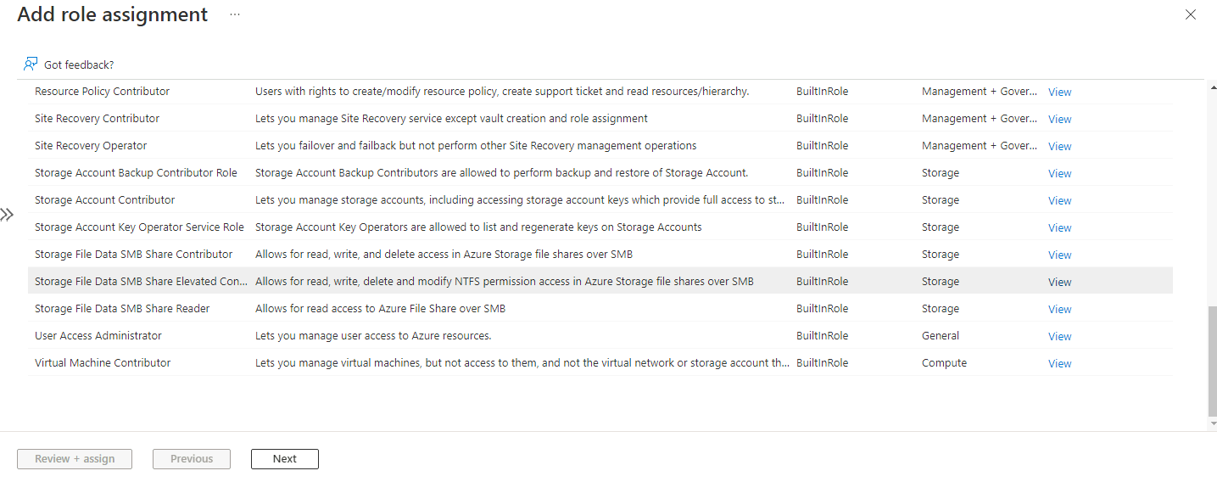

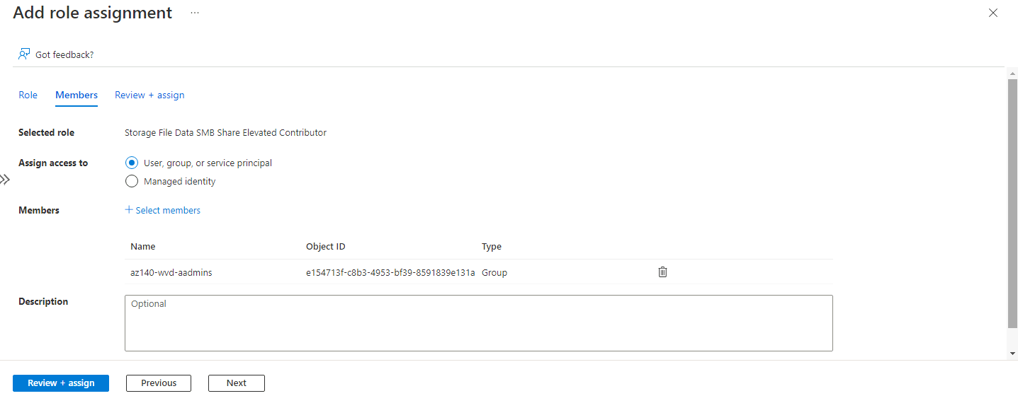

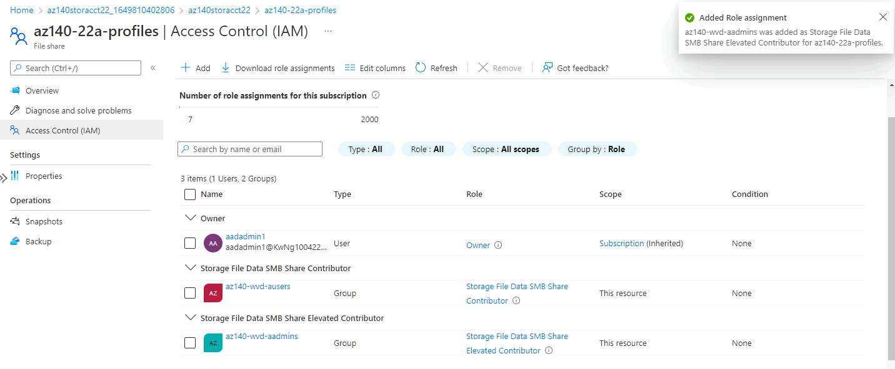

### Task 5: Configure the Azure Files directory and file level permissions

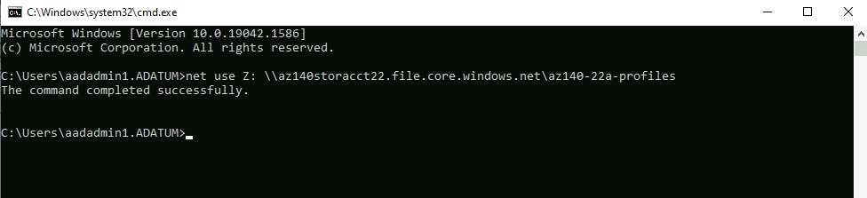

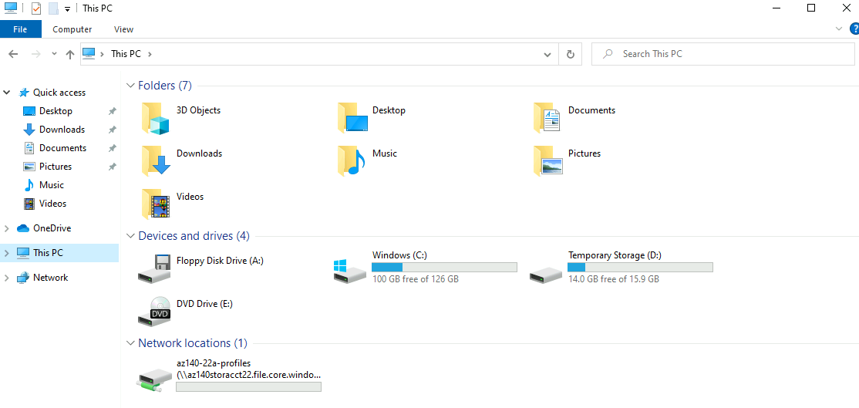

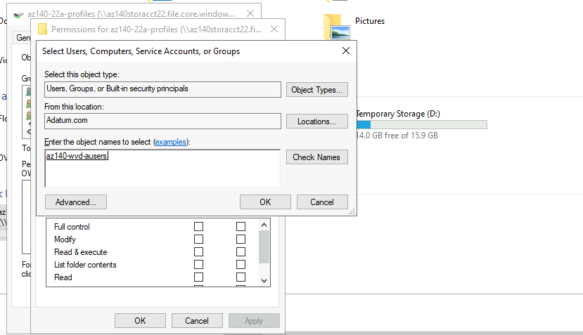

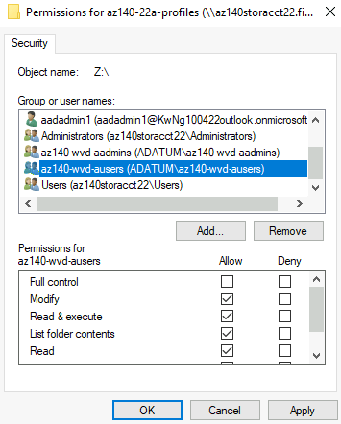 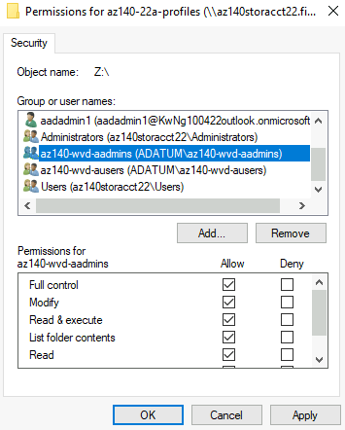 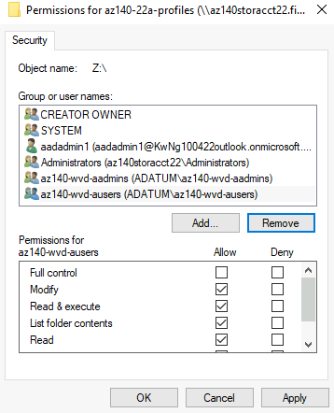

# Add az140-wvd-ausers with Modify permission level, add az140-wvd-aadmins with Full Control permission level and remove Authenticated Users and Users group

# Lab 04 - Implement and manage Azure Virtual Desktop profiles (Azure AD DS)

## Exercise 1: Implement FSLogix based profiles for Azure Virtual Desktop

### Task 1: Configure local Administrators group on Azure Virtual Desktop session host VMs

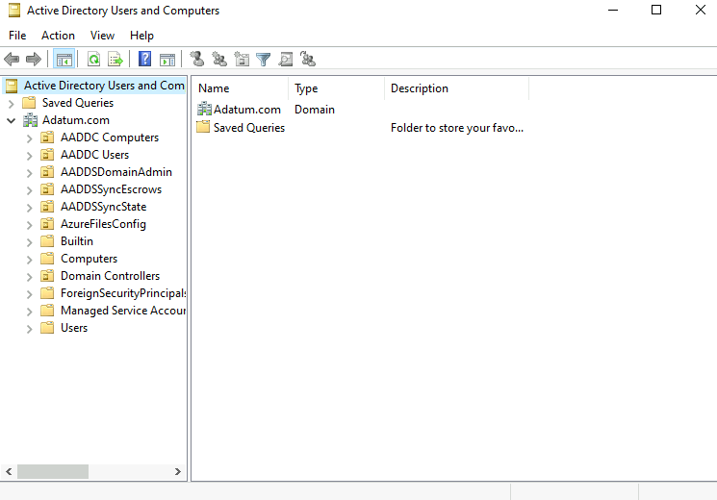

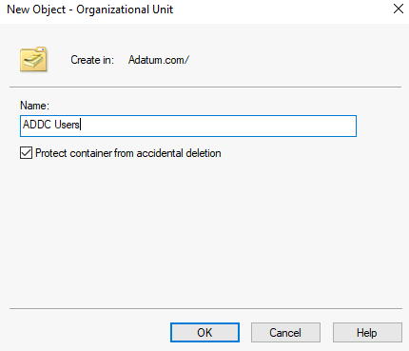 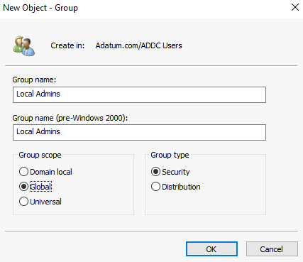

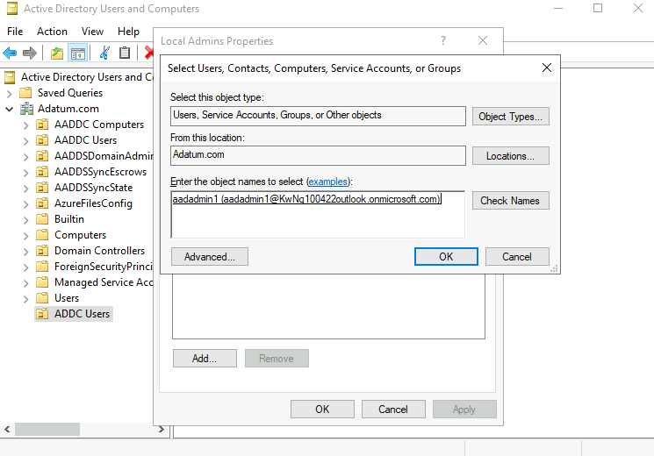

#Add wvdaadmin1 user into Local Admins group

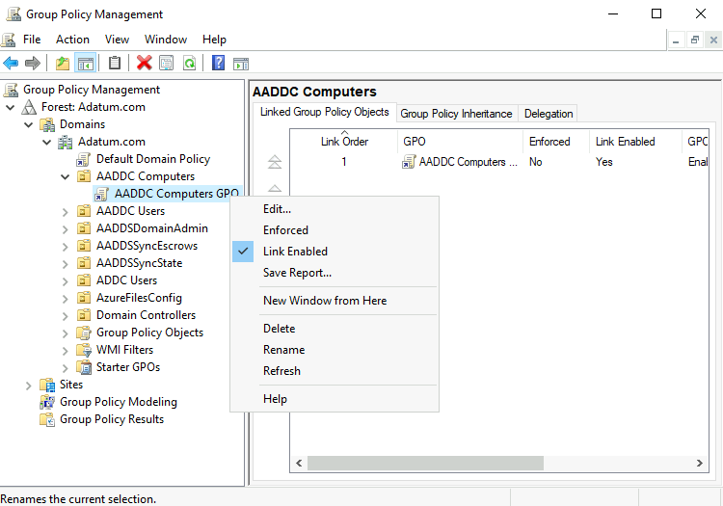

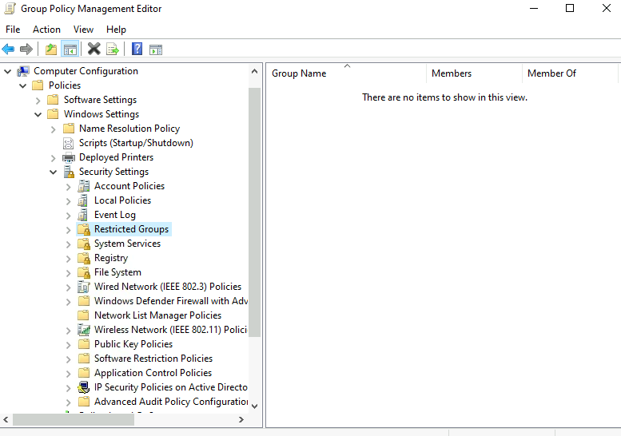

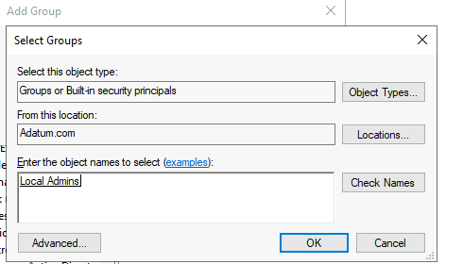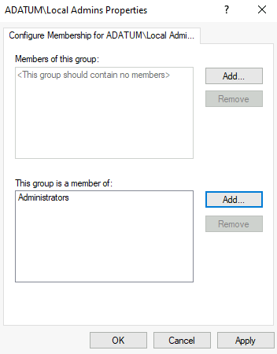

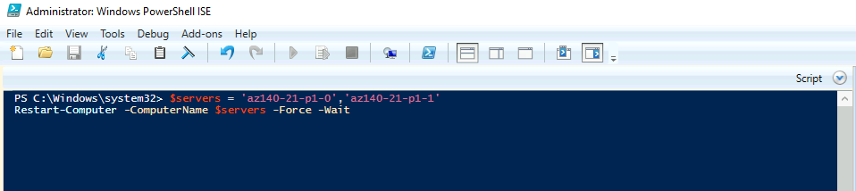

# Wait for the script to complete. This should take about 3 minutes

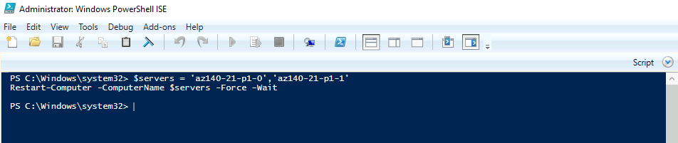

### Task 2: Configure FSLogix-based profiles on Azure Virtual Desktop session host VMs

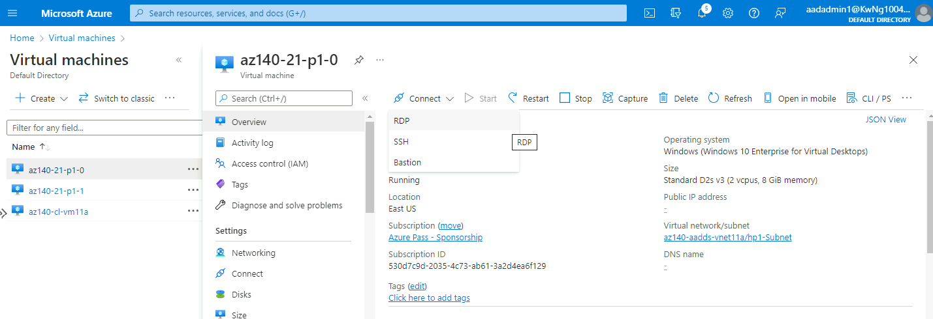

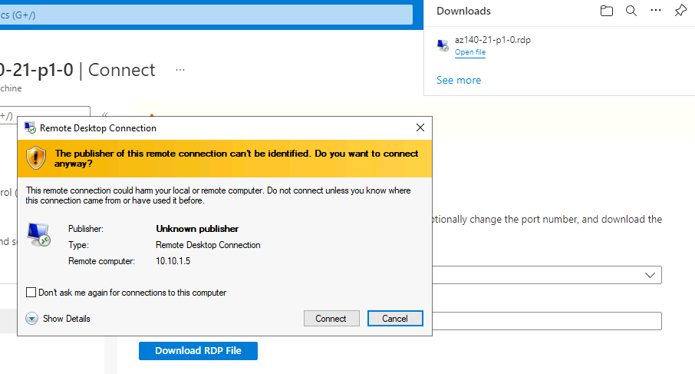

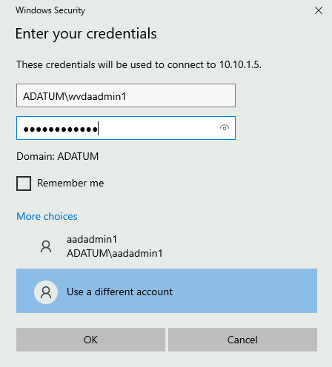

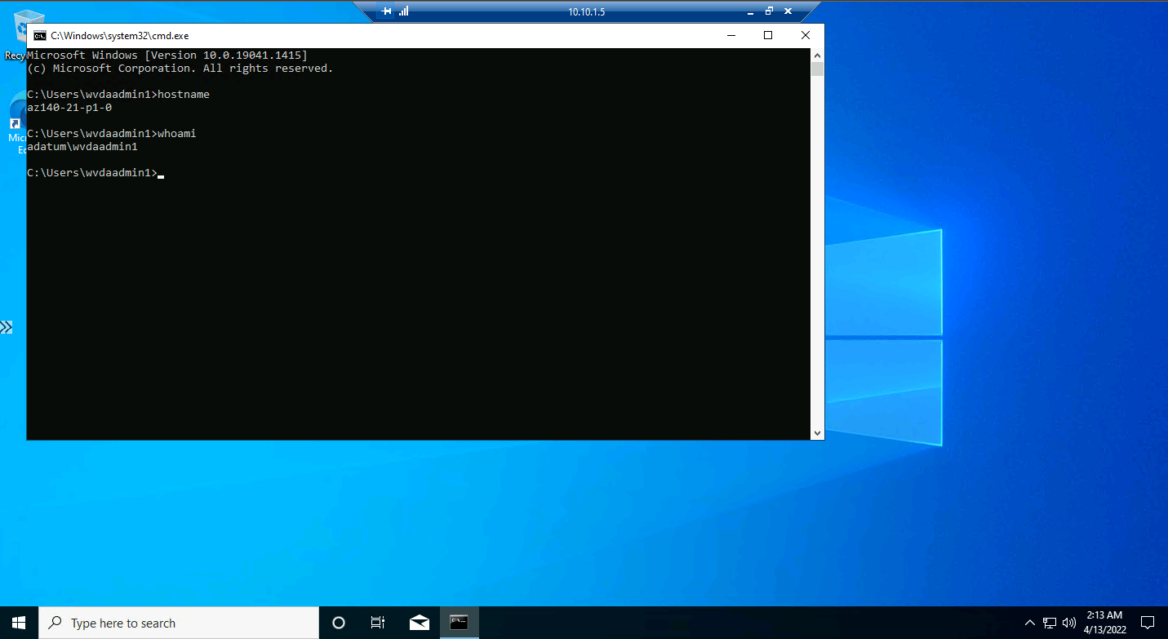

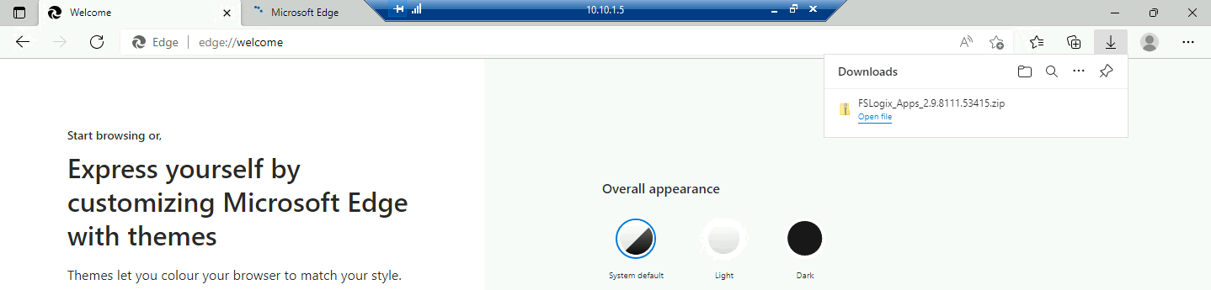

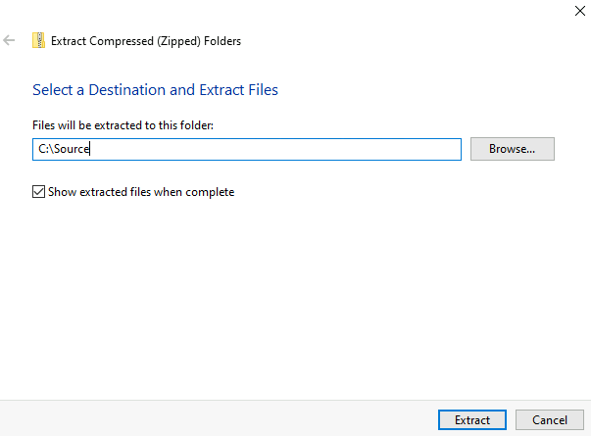

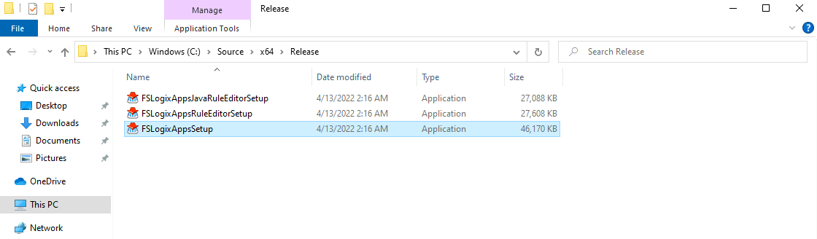

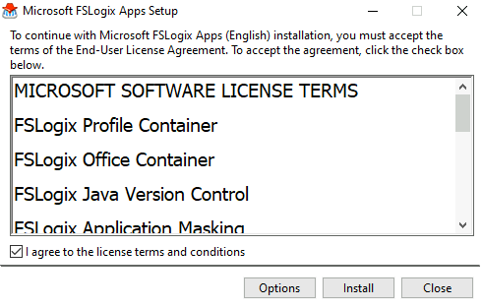 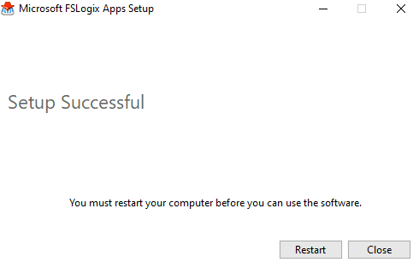

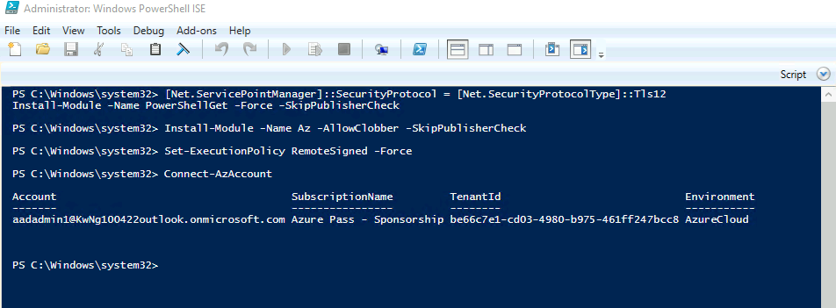

# Sign in using [aadadmin1@KwNg100422outlook.onmicrosoft.com](mailto:aadadmin1@KwNg100422outlook.onmicrosoft.com) and Pa55w.rd1234 for password

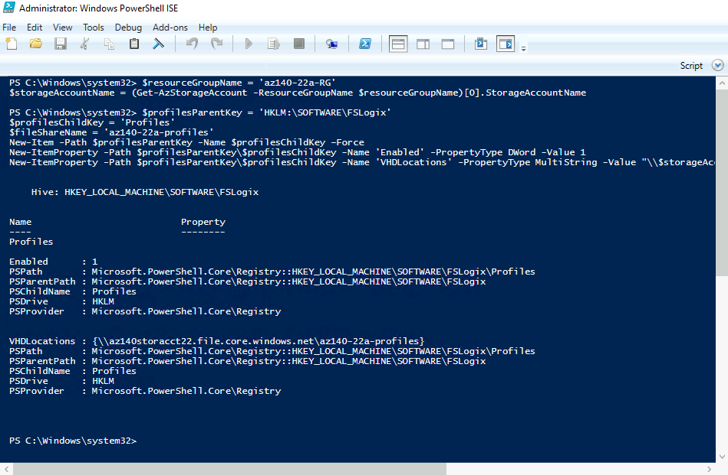

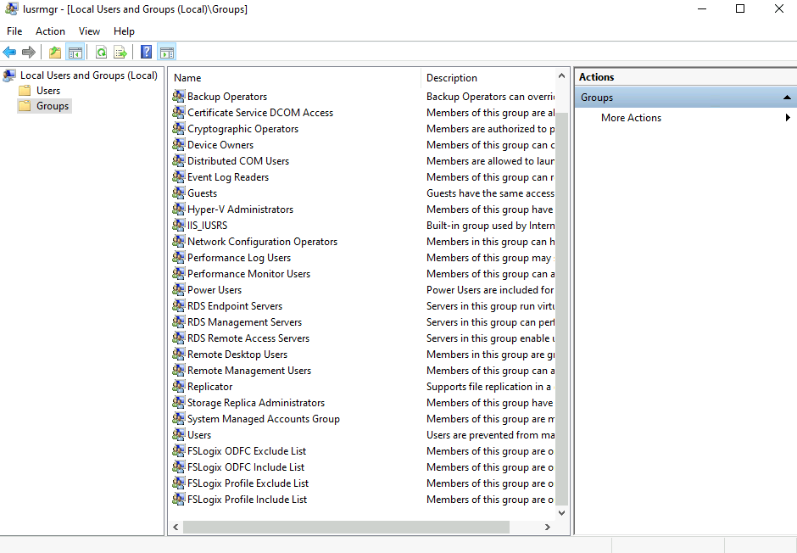

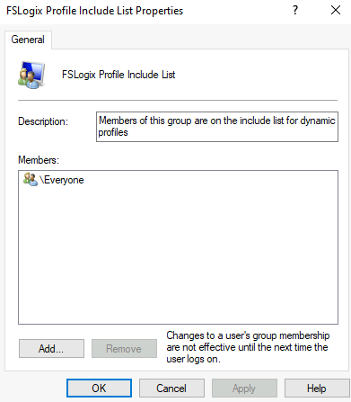 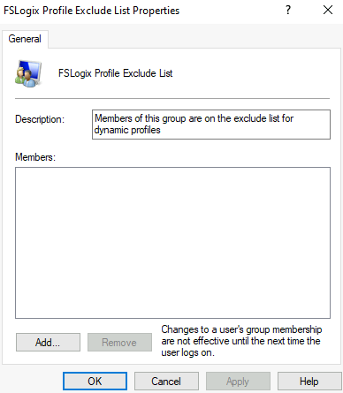

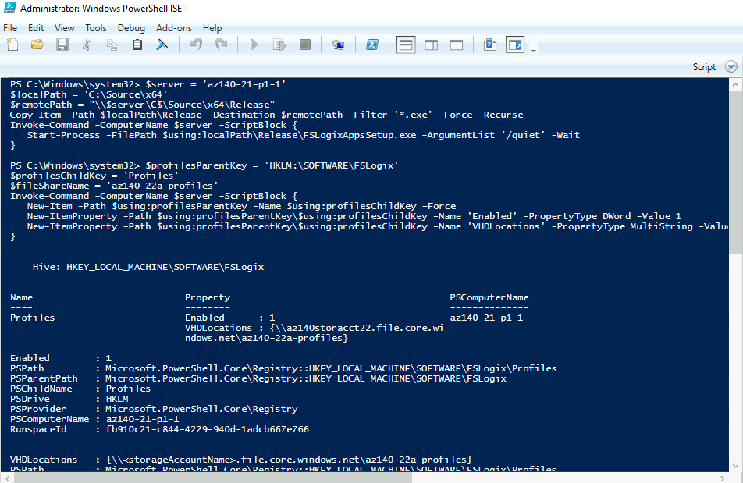

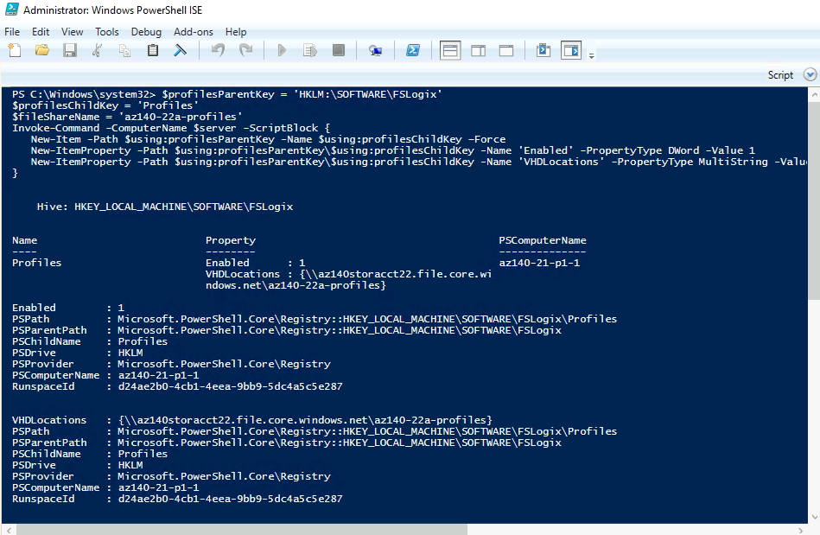

Note: Replace with actual name of your storage account

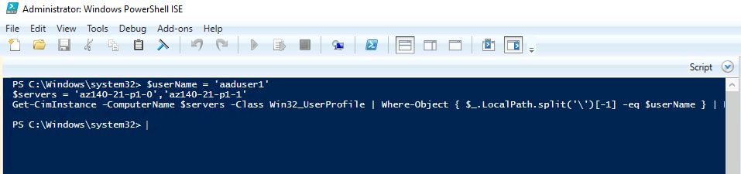

Note: Before you test the FSLogix-based profile functionality, you need to remove the locally cached profile of the ADATUM\wvdaadmin1 account you will be using for testing from the Azure Virtual Desktop session hosts you used in the previous lab

### Task 3: Test FSLogix-based profiles with Azure Virtual Desktop

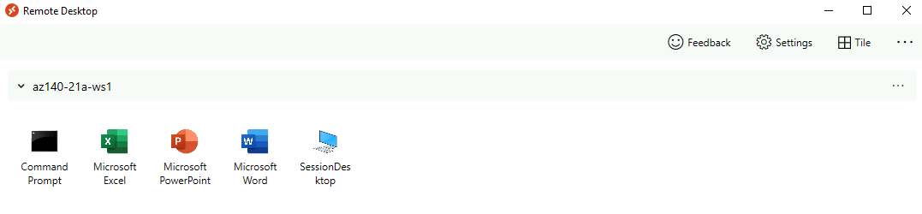

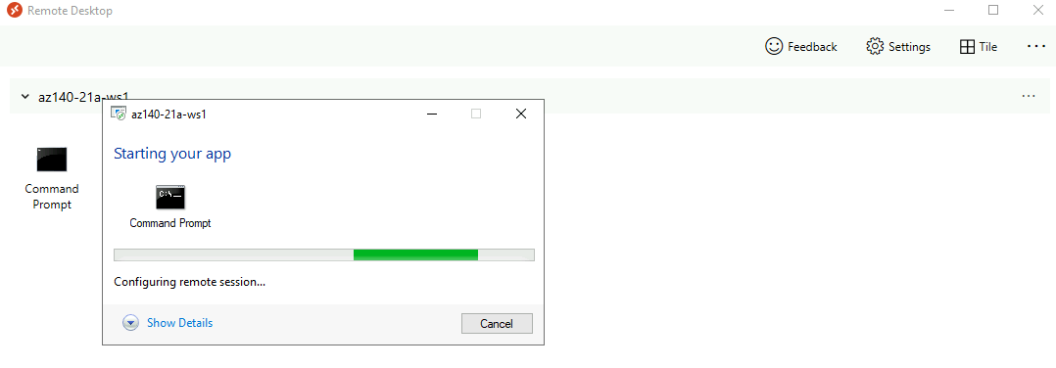

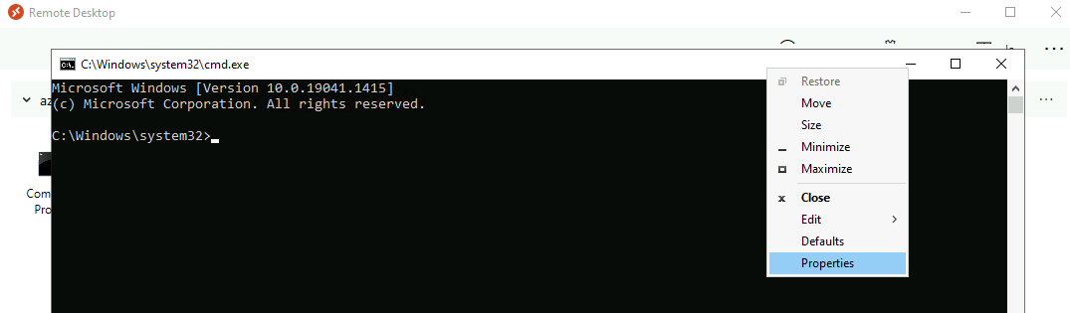

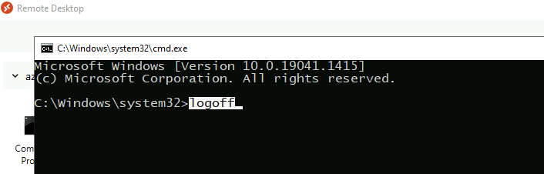

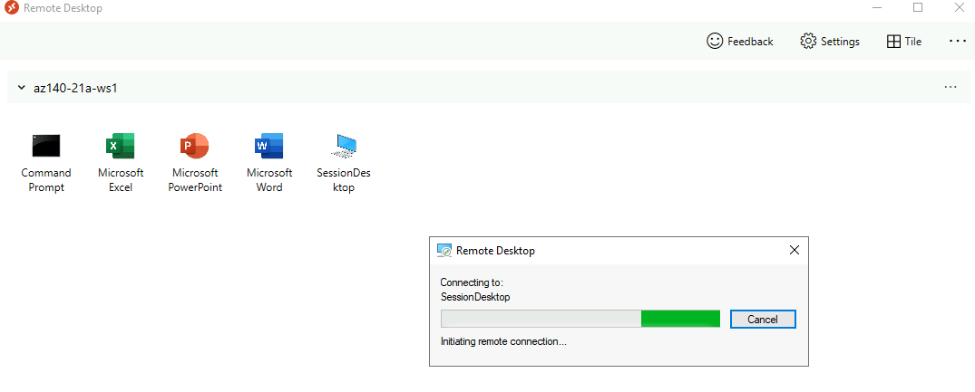

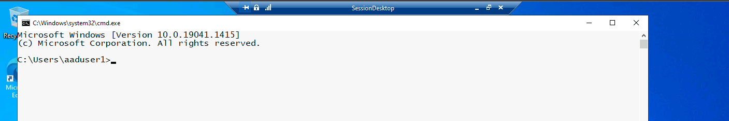

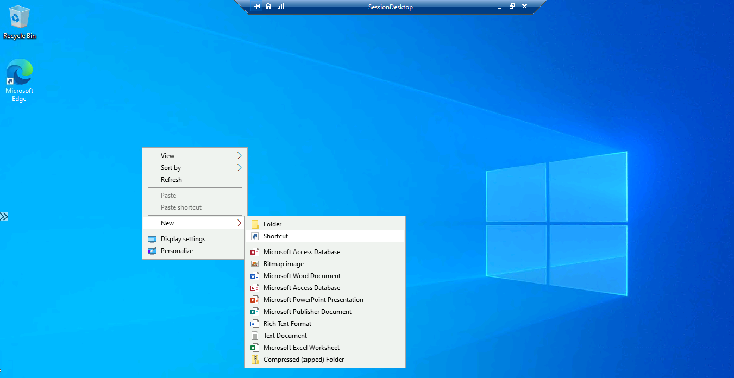

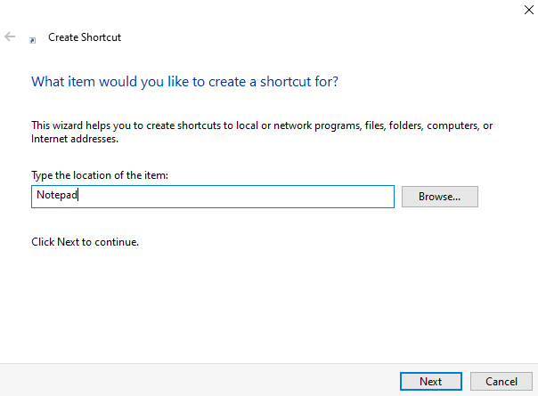 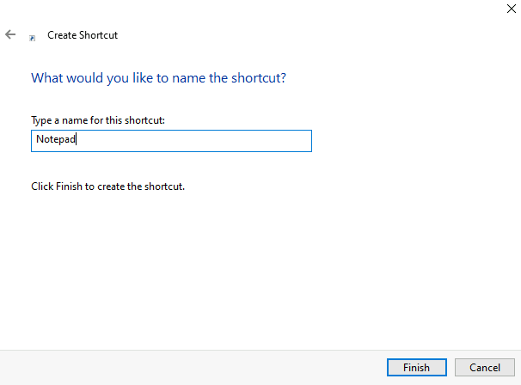

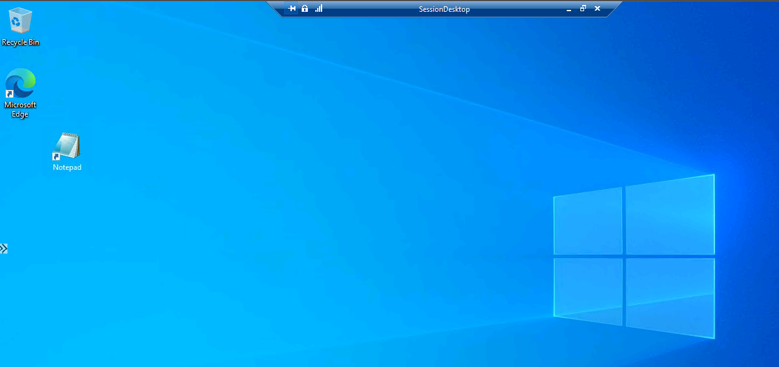

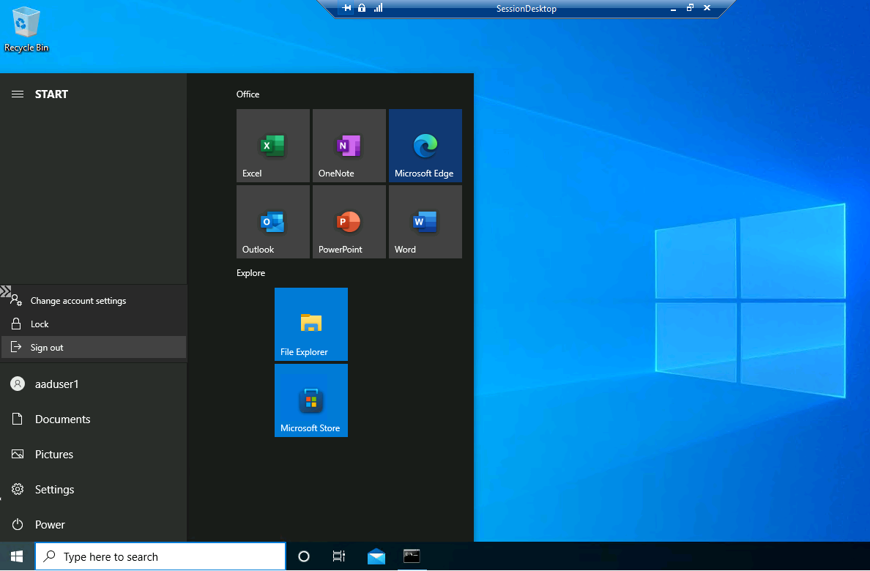

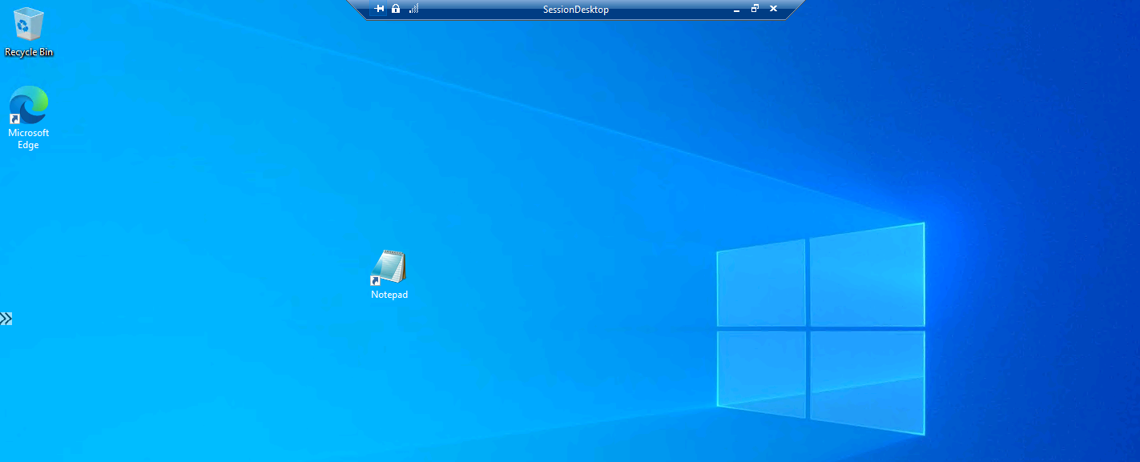

#Within the SessionDesktop session, verify that the Notepad shortcut appears on the desktop

